**

DRAFT REPORT – R1

*Fiscal Years 2018-2020*

MATC YeAR ONE rEport

Submitted by

Michael Sweigard

Graduate Research Assistant

Cody Stolle

Research Assistant Professor

Ricardo Jacome

Graduate Research Assistant

MIDWEST ROADSIDE SAFETY FACILITY

Nebraska Transportation Center

University of Nebraska-Lincoln

**Main Office**

Prem S. Paul Research Center at Whittier School

Room 130, 2200 Vine Street

Lincoln, Nebraska 68583-0853

(402) 472-0965

**Outdoor Test Site**

4630 NW 36th Street

Lincoln, Nebraska 68524

Submitted to

MID-AMERICA TRANSPORTATION CENTER

220 Vine Street

Lincoln, Nebraska 68583

MwRSF Research Report No. MwRSF-40042-01

October 15, 2018

|  |  |  |  |  |  |
| --- | --- | --- | --- | --- | --- |
| TECHNICAL REPORT DOCUMENTATION PAGE | | | | | |
| 1. Report No. | 2. | | | 3. Recipient’s Accession No. | |
| MwRSF-40042-01 |  | | |  | |
| 4. Title and Subtitle | | | | 5. Report Date | |
| MATC Year One Report | | | | October 15, 2018 | |
| 6. | |
|  | |
| 7. Author(s) | | | | 8. Performing Organization Report No. | |
| Sweigard, M.E., Jacome, R.O., and Stolle, C.S. | | | | MwRSF-40042-01 | |
| 9. Performing Organization Name and Address | | | | 10. Project/Task/Work Unit No. | |
| Midwest Roadside Safety Facility (MwRSF)  Nebraska Transportation Center  University of Nebraska-Lincoln | | | |  | |
| Main Office:  Prem S. Paul Research Center at Whittier School  Room 130, 2200 Vine Street  Lincoln, Nebraska 68583-0853 | | Outdoor Test Site:  4630 NW 36th Street  Lincoln, Nebraska 68524 | | 11. Contract (C) or Grant (G) No. | |
|  | |
| 12. Sponsoring Organization Name and Address | | | | 13. Type of Report and Period Covered | |
| Mid-America Transportation Center  220 Vine Street  Lincoln, Nebraska 68583 | | | | Draft Report: 2017-2018 | |
| 14. Sponsoring Agency Code | |
|  | |
| 15. Supplementary Notes | | | | | |
| Prepared in cooperation with U.S. Department of Transportation, Federal Highway Administration. | | | | | |
| 16. Abstract | | | | | |
| Run off road (ROR) crashes account for approximately 30% of all fatal vehicular crashes since 2014. These crashes result in billions of dollars in cost to society in terms of injury (treatment and hospitalization), lost productive work hours, increased traffic congestion, emergency response, reporting, and repairs to infrastructure due to impacts. Many recently-produced vehicles have driver assist systems (ADAS) that help the vehicle stay in the lane and prevent these types of crashes. However, these systems have significant limitations. The objective of this project is to develop a “Virtual Barrier” that communicates with vehicles to help the vehicle navigate the roadway.  The first phase of this project consisted of a thorough review of technologies used in smart vehicles and connected systems. These areas include: sensors, filtering techniques, vehicle detection, and path prediction; physics and methods of controlling vehicles during transit; vehicle-to-everything (V2X) communications; and cybersecurity. Most smart vehicle systems are not connected to any external data source. Decision-making for vehicle controls and path prediction are done locally (on the vehicle) using optical recognition (photographic), radar, LIDAR, and sonic measurements to optimize the path. Some extravehicular communication techniques have been utilized successfully, but to date, implementation is limited. | | | | | |
| 17. Document Analysis/Descriptors | | | 18. Availability Statement | | |
| Highway Safety, Run off road crashes, Path Prediction, Vehicle Controls, Inter-Vehicle Communication, Traffic Management | | | No restrictions. Document available from: National Technical Information Services, Springfield, Virginia 22161 | | |
| 19. Security Class (this report) | 20. Security Class (this page) | | 21. No. of Pages | | 22. Price |
| Unclassified | Unclassified | | 80 | |  |

DISCLAIMER STATEMENT

This report was completed with funding from the Mid-American Transportation Center. The contents of this report reflect the views and opinions of the authors who are responsible for the facts and the accuracy of the data presented herein. The contents do not necessarily reflect the official views or policies of the Mid-American Transportation Center. This report does not constitute a standard, specification, regulation, product endorsement, or an endorsement of manufacturers.

ACKNOWLEDGEMENTS

The authors wish to acknowledge several sources that made a contribution to this project: (1) Mid-America Transportation Center.; (2) Richard Stepp at Florida DOT; (3) David Boruff at Indiana DOT.

Acknowledgement is also given to the following individuals who made a contribution to the completion of this research project.

**Midwest Roadside Safety Facility**

R.K. Faller, Ph.D., P.E., Research Associate Professor & MwRSF Director

J.D. Reid, Ph.D., Professor

J.D. Schmidt, Ph.D., P.E., Research Assistant Professor

J.C. Holloway, M.S.C.E., E.I.T., Test Site Manager

K.A. Lechtenberg, M.S.M.E., E.I.T., Research Engineer

R.W. Bielenberg, M.S.M.E., E.I.T., Research Engineer

S.K. Rosenbaugh, M.S.C.E., E.I.T., Research Engineer

M. Asadollahi Pajouh, Ph.D., Former Post-Doctoral Research Assistant

S.A. Ranjha, Ph.D., Former Post-Doctoral Research Assistant

A.T. Russell, B.S.B.A., Testing and Maintenance Technician II

F. Bai, Ph.D. Post-Doctoral Research Assistant

S.M. Tighe, Construction and Testing Technician I

D.S. Charroin, Construction and Testing Technician I

M.A. Rasmussen, Construction and Testing Technician I

E.W. Krier, Construction and Testing Technician II

M.T. Ramel, Construction and Testing Technician I

R.M. Novak, Construction and Testing Technician I

J.E. Kohtz, B.S.M.E., CAD Technician

E.L. Urbank, B.A., Research Communication Specialist

Undergraduate and Graduate Research Assistants

|  |  |  |  |  |
| --- | --- | --- | --- | --- |
| SI* (MODERN METRIC) CONVERSION FACTORS | | | | |
| **APPROXIMATE CONVERSIONS TO SI UNITS** | | | | |
| **Symbol** | **When You Know** | **Multiply By** | **To Find** | **Symbol** |
| **LENGTH** | | | | |
| in. | inches | 25.4 | millimeters | mm |
| ft | feet | 0.305 | meters | m |
| yd | yards | 0.914 | meters | m |
| mi | miles | 1.61 | kilometers | km |
| **AREA** | | | | |
| in2 | square inches | 645.2 | square millimeters | mm2 |
| ft2 | square feet | 0.093 | square meters | m2 |
| yd2 | square yard | 0.836 | square meters | m2 |
| ac | acres | 0.405 | hectares | ha |
| mi2 | square miles | 2.59 | square kilometers | km2 |
| **VOLUME** | | | | |
| fl oz | fluid ounces | 29.57 | milliliters | mL |
| gal | gallons | 3.785 | liters | L |
| ft3 | cubic feet | 0.028 | cubic meters | m3 |
| yd3 | cubic yards | 0.765 | cubic meters | m3 |
| 1. NOTE:volumes greater than 1,000 L shall be shown in m3 | | | | |
| **MASS** | | | | |
| oz | ounces | 28.35 | grams | g |
| lb | pounds | 0.454 | kilograms | kg |
| T | short ton (2,000 lb) | 0.907 | megagrams (or “metric ton”) | Mg (or "t") |
| **TEMPERATURE (exact degrees)** | | | | |
| °F | Fahrenheit | 5(F-32)/9  or (F-32)/1.8 | Celsius | °C |
| **ILLUMINATION** | | | | |
| fc | foot-candles | 10.76 | lux | lx |
| fl | foot-Lamberts | 3.426 | candela per square meter | cd/m2 |
| **FORCE & PRESSURE or STRESS** | | | | |
| lbf | poundforce | 4.45 | newtons | N |
| lbf/in2 | poundforce per square inch | 6.89 | kilopascals | kPa |
| **APPROXIMATE CONVERSIONS FROM SI UNITS** | | | | |
| **Symbol** | **When You Know** | **Multiply By** | **To Find** | **Symbol** |
| **LENGTH** | | | | |
| mm | millimeters | 0.039 | inches | in. |
| m | meters | 3.28 | feet | ft |
| m | meters | 1.09 | yards | yd |
| km | kilometers | 0.621 | miles | mi |
| **AREA** | | | | |
| mm2 | square millimeters | 0.0016 | square inches | in2 |
| m2 | square meters | 10.764 | square feet | ft2 |
| m2 | square meters | 1.195 | square yard | yd2 |
| ha | hectares | 2.47 | acres | ac |
| km2 | square kilometers | 0.386 | square miles | mi2 |
| **VOLUME** | | | | |
| mL | milliliter | 0.034 | fluid ounces | fl oz |
| L | liters | 0.264 | gallons | gal |
| m3 | cubic meters | 35.314 | cubic feet | ft3 |
| m3 | cubic meters | 1.307 | cubic yards | yd3 |
| **MASS** | | | | |
| g | grams | 0.035 | ounces | oz |
| kg | kilograms | 2.202 | pounds | lb |
| Mg (or "t") | megagrams (or “metric ton”) | 1.103 | short ton (2,000 lb) | T |
| **TEMPERATURE (exact degrees)** | | | | |
| °C | Celsius | 1.8C+32 | Fahrenheit | °F |
| **ILLUMINATION** | | | | |
| lx | lux | 0.0929 | foot-candles | fc |
| cd/m2 | candela per square meter | 0.2919 | foot-Lamberts | fl |
| **FORCE & PRESSURE or STRESS** | | | | |
| N | newtons | 0.225 | poundforce | lbf |
| kPa | kilopascals | 0.145 | poundforce per square inch | lbf/in2 |
| *SI is the symbol for the International System of Units. Appropriate rounding should be made to comply with Section 4 of ASTM E380. | | | | |

TABLE OF CONTENTS

TECHNICAL REPORT DOCUMENTATION PAGE i

DISCLAIMER STATEMENT ii

ACKNOWLEDGEMENTS ii

SI* (MODERN METRIC) CONVERSION FACTORS iii

1 INTRODUCTION 1

1.1 Problem Statement 1

1.2 Objective 1

1.2.1 Overall Objective 1

1.2.1 Scope 2

2 CURRENT MARKET 3

2.1 Frontal Impact Mitigation 3

2.1.1 Forward Collision Warning 4

2.1.2 Collision Mitigation Braking 4

2.2 Lateral Impact Mitigation 5

2.2.1 Blind Spot Warning 6

2.2.2 Lane Departure Warning 6

2.2.3 Lane Keeping Assistance 6

2.3 Adaptive Cruise Control 7

3 SENSOR TECHNOLOGIES 7

3.1 Sensors Specifications & Working Principles 9

3.1.1 Steering Wheel Angles 10

3.1.1.1 Magnetostatic Sensor 13

3.1.1.2 Hall Sensor 13

3.1.1.3 Magnetically Inductive Sensor 14

3.1.1.4 Potentiometer 15

3.1.2 Vehicle Wheel Speeds/ RPMs 16

3.1.2.1 Magnetic Sensors 16

3.1.2.2 Tachometer 17

3.1.3 Vehicle Angular Rates 17

3.1.3.1 Gyrometers 18

3.1.4 Vehicle Accelerations 19

3.1.4.1 Accelerometers 20

3.1.5 Vehicle Environment Recognition 22

3.1.5.1 Radar Sensors 22

3.1.5.2 Ultrasonic Sensors 25

3.1.5.3 Lidar 26

3.1.5.1 Video Sensors 28

3.1.5.1 Video Sensors 30

3.1.6 Machine Learning 31

3.1.7 Vehicle GPS Sensor Location 33

4 DATA FILTERS 34

4.1 Kalman Filter 35

4.2 Extended Kalman Filter 38

4.3 Unscented Kalman Filter 40

5 VEHICLE CONTROL 41

5.1 Vehicle Control 41

5.2 ABS Control 43

5.3 Path Prediction 46

5.4 Vehicle Communications 48

6 TRAFFIC MANAGEMENT 49

6.1 Intersection Control 49

6.2 Pedestrian Detection 49

6.3 Vehicle Platooning 50

6.4 Vehicle Communications 50

6.5 Emergency Response 51

6.5.1 Emergency Vehicle Preemption 51

6.5.2 Emergency Vehicle V2V Communication 52

6.5.3 Accident Notification 52

7 CYBERSECURITY 53

8 SUMMARY AND FURTURE WORK 55

8.1 Report Summary 55

8.2 Future Work 56

9 REFERENCES 57

10 APPENDICES 64

Appendix A. Current Vehicle Sensors 65

LIST OF FIGURES

Figure 1 Examples of ROR Crashes (images take from NHTSA’s NASS CDS) 1

Figure 2 SAE Convention Vehicle X-Axis 4

Figure 3. Forward Vehicle Detection Honda Sensing 4

Figure 4. Forward Collision Detection from Honda Sensing 5

Figure 5 SAE Convention Vehicle Z-Axis 6

Figure 6. Blind Spot Vehicle Detection & Warning Honda Sensing 6

Figure 7. Lane Detection System Honda Sensing 7

Figure 8. Transducer Flowchart for Signal Acquisition based on Different Inputs [22] 9

Figure 9 Steering Angle Classification 11

Figure 10 Steering Wheel Sensor Example 11

Figure 11 Steering Wheel Basic Measurement Principle 12

Figure 12 Hall Effect for Measurement 14

Figure 13. Magnetically Inductive Sensor Approach 15

Figure 15 Wheel Speed Sensor Location 16

Figure 16 Tachometer Types 17

Figure 17 Example of Gyroscope and Axis of Rotation 18

Figure 18 Gyroscope Mechanical Model Extracted from [73] 19

Figure 19 Accelerometers Comparison 20

Figure 20 Mass-Spring System with Input Force 20

Figure 21 Accelerometer Measurement Concept 21

Figure 22 Radar Sensor and Specifications manufactured by BOSCH [75] 25

Figure 23 Ultrasonic Sensor used in vehicle manufactured by BOSCH 26

Figure 24 Examples of Lidar Sensors as manufactured by Velodyne 27

Figure 25 Stereo Vision Sensor manufactured by DENSO 29

Figure 26 Optimized Prediction Function through Gradient Descent. 33

Figure 27. Kalman Filter Iterative Procedure [24] 36

Figure 28 Combination of Gaussian Probability Distributions 37

Figure 29. Extended Kalman Filter Iterative Procedure 38

Figure 30. Block Diagram for Longitudinal Control System in a Standard Cruise Control 42

Figure 31. Slip Ratio vs Friction Coefficient [15] 44

Figure 32. Diagram of Vehicle Bicycle Model [38]. 47

Figure A-1. Sensors Available on Current Vehicles 66

Figure A-2. Sensors Available on Current Vehicles 67

LIST OF TABLES

Table 1 Energy Domain Transformations [22] 8

Table 2 Vehicle Sensors Comparisons in Parameter/Application/Price 9

Table 3 Specifications for Steering Wheel Angles 12

Table 4 Vehicle Dynamics Model and Controller for Commercial Use 42

Table 5 Average deceleration value for all tested configurations [16] 44

Table 6 Coefficients of Friction for Different Roads [17] 45

1. INTRODUCTION
   1. Problem Statement

The Federal Highway Administration (FHWA) reported that approximately 53% of fatal crashes (18,779) between 2014 and 2016 were related to roadside departures or lane departures [29]. Overall approximately 1/3 of more than 30,000 annual traffic fatalities are attributable to run-off-road (ROR) crashes. It can be seen from these statistics that these types of accidents account for a large percentage for fatal accidents on the road.

Most of these crashes can be categorized into the following: drift off road, overcorrection, failure to negotiate curve, and avoidance maneuver.

* Drift Off Road: vehicle slowly departs roadway (typically at a small angle of departure and straight-line trajectory). This condition is most commonly associated with drowsy or impaired drivers, or drivers with medical episodes.
* Overcorrection: the vehicle experiences a path change (drift out of lane, lane change, avoidance maneuver), then the driver overcompensates and over-steers while attempting to guide the vehicle back to the desired lane. This roadside departure type commonly results in spinout and skidding.
* Failure to Negotiate Curve: vehicle veers to the outside of a curve. Condition is frequently associated with high travel speeds or poor pavement friction (e.g., ice).
* Avoidance Maneuver: vehicle performs evasive maneuver to avoid crashing into an object, person, or animal in lane. This roadside departure condition is commonly associated with higher travel speeds (e.g., freeway), and is abrupt and panicked.

Examples of these categories can be seen in Figure 1.

|  |  |
| --- | --- |
| 134002987--tree--scene  (a) Drift-Off Road | 134002687--tree--scene  (b) Overcorrection / Oversteering |
| 134003225-trj-rotated  (c) Failure to Negotiate Curve | 146000714--avoidance-stalled-vehicle  (d) Avoidance Maneuver |

Figure 1 Examples of ROR Crashes (images take from NHTSA’s NASS CDS)

New technology is installed in modern vehicles to help reduce the frequency of ROR excursions. Advanced driver-assistance systems (ADAS) assist the driver by identifying the geometry of the road using lane markings to help keep the driver on the road [30-32]. However these systems are subject to considerable limitations. They are not able characterize the geometry of the road way in all conditions, and may be affected by weather, lighting, false readings, or the lack of road markings.

* 1. Objective
     1. Overall Objective

The objective of this project is to develop a vehicle-to-roadside infrastructure (V2I) system which can assist the vehicle in remaining on the roadway.

* + 1. Scope

This research study corresponds to Year 1 of the Smart Barrier project. To complete Year 1 objectives, researchers performed an extensive literature review, including a summary of vehicle sensors and filtering techniques, vehicle control techniques, and modern Advanced Driver Assist Systems (ADAS). This summary report describes the findings from Year 1.

The second year of the project will involve modeling various part of the overall system including vehicle controls, vehicle dynamics and road geometry modeling. Year three will include the validation of modeling done in year two and continuous updating and finalizing the model. Year four will begin prototyping and compiling hardware to implement the system. Year five of the project will involve testing the full system and assembling the results. Outlined in this report is the results of the first year’s results.

1. CURRENT MARKET

Private companies offer vehicle technologies with different semi-autonomous features. However, most of them are not reliable under all conditions and therefore cannot be always relied upon to. Current ADAS rely on a variety of independent sub-systems. These systems are available as either baseline or optional upgrade features in almost all commercial models starting from 2016 onwards [46, 47, 48, 49, 50]. As per the National Highway Traffic Safety Administration (NHTSA), automated vehicles are classified by a level of autonomy as follows [51]:

* Level 0- No Automation. Driver perform all driving tasks.
* Level 1- Driver Assistance. Vehicle is controlled by driver, with some assist features
* Level 2- Partial Automation. Vehicle has automated functions like steering and braking but the driver must remain engaged during all driving operations.
* Level 3- Conditional Automation. Driver is a necessity, but not always required to monitor the environment. Driver must be ready to take control at any moment.
* Level 4- High Automation. Vehicle can perform all driving functions under certain conditions. Driver may choose to drive or surrender control to the vehicle.
* Level 5- Full Automation. Vehicle can perform all driving functions under all conditions. Driver may choose to drive or surrender control to the vehicle.

At the close of year 2018, some new production vehicles have reached Level 4 Automation, and many new and recently-manufactured vehicles are classified as Level 3 Conditional Automation. No vehicles are classified as Level 5 Full Automation, as a large number of caveats, challenges, and difficult travel environments pose problems for vehicle controls.

The current market for ADAS is categorized in two main areas; Lateral Impact Mitigation (LIM) and Frontal Impact Mitigation (FIM). Both LIM and FIM can be split into two different modes of operation: passive and active. Passive LIM and FIM systems warn drivers, while Active LIM and FIM manipulate the vehicle’s braking/throttling behavior.

* 1. Frontal Impact Mitigation (FIM)

FIM systems work through a control algorithm that monitors vehicle’s longitudinal direction, as shown in Figure 2. For this type of application, the controller is known as a “longitudinal control system”. This controller takes two types of inputs, the first one being sensor information about the vehicle such as the vehicle current wheel speed and heading angle. The second input being environment information such as object/pedestrian detection through visual or radio sensors. With this information, the controller decides whether it is appropriate to adjust the current longitudinal vehicle speed. What sensors/systems are used depend on the features available on the individual vehicle [53, 54].

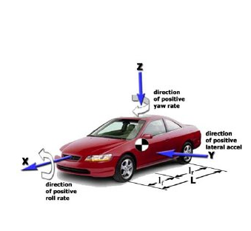

Figure 2 SAE Convention Vehicle X-Axis [ref]

* + 1. Forward Collision Warning

Forward Collision Warning (FCW) is a sub-category of FIM systems. Most recent vehicle technologies use Machine Learning algorithms for object recognition along with current sensor technologies. This system can be composed of (but is not limited to) frontal cameras, radars, and ultrasonic sensors. Based on approximated vehicle-to-vehicle distance, a time for collision is calculated. The Electronic Control Unit (ECU) then determines whether a collision is probable based on current trajectory and warn the driver to take preventive action. The warning signal can be displayed on the vehicle by different media such as warning signs on the panel or the mirrors [52].

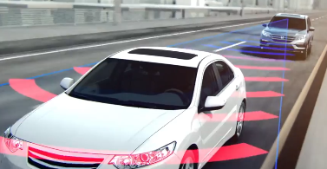

Figure 3. Forward Vehicle Detection Honda Sensing [ref]

* + 1. Collision Mitigation Braking

Collision Mitigation Braking (CMB) is another sub-category for FIM systems. This system uses (but it is not limited to) frontal cameras, radars, and ultrasonic sensors to detect vehicles and other objects that pose a risk. CMB is an active system since it can take control of the brakes to avoid forward collisions. Based on the current vehicle velocity, the detected motion of the other vehicle, and approximate vehicle-to-vehicle distance from sensors, braking decisions are performed by the ECU [54, 55]. CMB works in a similar principle as FCW, but in terms of precision, CMB works under a smaller time frame. For example, CMB takes decisions to brake in milliseconds since it is an active system. However, FCW takes less computing capacity since it does not have to take corrective action.

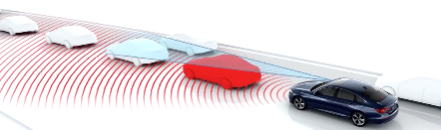

Figure 4. Forward Collision Detection from Honda Sensing [ref]

Research involving FIM involves development in many aspects such as increasing efficiency in: object recognition, use of vehicle communications, finding new parameters that affect braking conditions. Examples of these are found on the references section [56, 57, 58].

* 1. Lateral Impact Mitigation

Autonomous systems that monitor and control the vehicle’s steering system are referred to as “lateral control systems”. These systems maintain a driving direction in reference to the lanes and monitor vehicles coming from lateral directions. To do this, the lateral direction of the vehicle is controlled through steering, braking or a combination of both. Maintaining straight line driving does not require much control compared to curved roads. For this reason, most ADAS lane changing maneuvering is performed by drivers. The sensors employed by LIM include a range similar to the ones in FIM for object detection. Like FIM, these systems can be either passive, which only involves warning drivers based on sensors, or active, which adjusts the steering wheel or brakes. There are three sub-systems that are used in modern vehicles for lateral impact mitigation: blind spot warning; lane departure warning; and lane keeping assist.



Figure 5 SAE Convention Vehicle Z-Axis [ref]

* + 1. Blind Spot Warning

The blind sport warning system is a LIM passive system that monitors the environment around the car. This system uses a series of cameras and radar sensors to detect vehicles approaching the blind spot of the vehicle. Also, steering wheel sensors are used to make predictions about vehicle motion. Then, based on the proximity of the incoming vehicle to the host vehicle, the user’s vehicle velocity, and steering angle inputs from the driver, the ECU can predict if there is an imminent collision and warn the driver about it ahead of time.

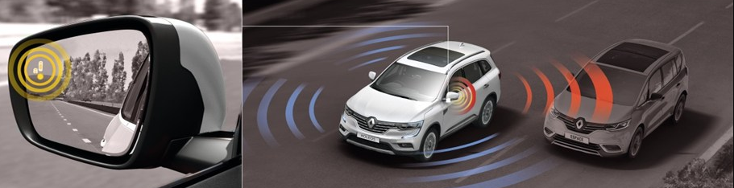

Figure 6. Blind Spot Vehicle Detection & Warning Honda Sensing [ref]

* + 1. Lane Departure Warning

The lane departure warning system is a passive LIM system that warns drivers when the vehicle is deviating from its current lane. This system uses frontal cameras and image processing to detect road lane markings. If the steering wheel sensor detects an angle that will cause a lane change, a time of approach is calculated to determine how quickly the vehicle will exit the lane. The ECU estimates whether a lane departure is imminent and if so, warn drivers about it.

* + 1. Lane Keeping Assistance

Lane Keeping Assistance is an active LIM system which resists the vehicle from leaving its current lane. This system utilizes the same inputs as the lane departure warning system. It observes the lane profile and estimates the time to cross the lane edge based on the steering input sensor. The ECU will actively adjust the steering angle of the vehicle to keep the vehicle within its lane instead of just warning the driver.

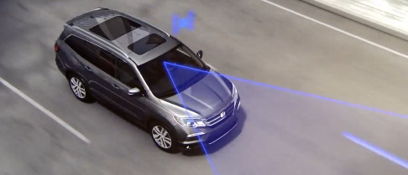

Figure 7. Lane Detection System Honda Sensing

Research on LIM system involves creating new control algorithms for the ECU to: monitor the lanes, control steering wheel angles, use of new sensors to increase the efficiency of steering wheel corrections, and use of infrastructure communications. Examples of these research techniques are offered on the References Section [59, 60, 61, 62, 63, 64].

* 1. Adaptive Cruise Control

The ADAS known as Adaptive Cruise Control (ACC) activates both FIM and LIM technologies simultaneously. Most current vehicles offer ACC from their 2016 models onwards with at least a level 3 of autonomy. ACC uses both lateral and frontal sensors, control systems, and path prediction algorithms to achieve the most suitable driving experience. Under optimal conditions, ACC is capable of driving at constant speed, while maintaining a lane, turning on constant radii, brake if necessary, and adjust speed to match upcoming traffic flow. New challenges arise from combining both technologies revolving about combining both steering and braking within a single system. For this reason, current ACC systems only use a hierarchy of LIM and FIM. This hierarchy is being studied in research by using model predictive controllers, and time to lane changes [65, 66, 67, 68]

1. SENSOR TECHNOLOGIES

Sensors convert an energy quantity into signal information which can be analyzed through software. These signals carry energy of a system from different domains such as

* Chemical
* Magnetic
* Mechanical
* Thermal
* Radiant
* Electrical

When a device transforms one energy type to a different one, is called a transducer. A sensor can contain multiple transducers to convert the input signal to a different output signal. Examples include pressure transducer with take a mechanical input and converts it into an electrical output. A summary list of the main energy transformations is shown in Table 1

Table 1 Energy Domain Transformations [22]

|  |  |  |  |  |  |  |
| --- | --- | --- | --- | --- | --- | --- |
| Output | Radiant | Mechanical | Thermal | Electrical | Magnetic | Chemical |
| Input |  |  |  |  |  |  |
| Mechanical | Photo elasticity | Transfer of Momentum | Friction Heat | Piezo-electricity | Magneto-striction | Pressure-Induced Explosion |
| Thermal | Incandescence | Thermal Expansion | Heat Conduction | Seebeck Effect | Curie-Weiss Law | Endothermic Reaction |
| Electrical | Inject Luminescence | Piezo-electricity | Peltier Effect | pn junction effect | Ampere's Law | Electrolysis |
| Magnetic | Faraday Effect | Magneto-striction | Ettinghausen effect | Hall Effect | Magnetic Induction |  |
| Chemical | Chemi-luminescence | Explosive reaction | Exothermic Reaction | Voltaic Effect |  | Chemical Reaction |

For computational analysis, all sensors give electrical output signals. These electrical signals are limited to voltages, currents or frequencies. To achieve the desired electrical signals, the following variations are possible:

* Change in Resistance
* Change in Capacitance
* Change in Inductance
* Change in Frequency

Sensors must contain at least one electrical transducer that imports signals to an electrical output which can be read by a data acquisition system. The transferability of signals allows intermediate exchanges between inputs and outputs which could be monitored and recorded, or if electrical conversion is used, digitally logged. An example of signal transference for electrical acquisition and digital storage is shown in Figure 8.

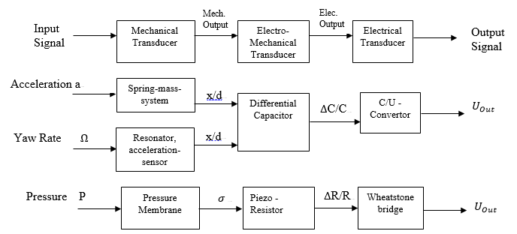

Figure 8. Transducer Flowchart for Signal Acquisition based on Different Inputs [22]

* 1. Sensors Specifications & Working Principles

Sensors may be classified as more than one type. Also, different sensors can be used for the same application. The Bosch Automotive Handbook [23] gives some classification options as shown in Table 2. A complete review table for Autonomous Driving Sensors is found in Appendix A.

Assignment and Application - This contains sensors with specific functions such as temperature sensors, focusing on open or closed loop control functions. Sensors for safety and protection, such as airbag deployment or the Electronic Stability Program (ESP).

Type of Characteristic Error Curve - This includes different behaviors resulting from deviations of the ideal output signal being measured. The classification includes nonlinearities, offsets, hysteresis, and quantization errors [22].

Type of Output Signal - The output can be either analog or discrete. For analog outputs, different currents/voltages, frequencies/periods of duration, or pulse duration can be used. For discrete outputs, dual stage (binary encoded) and multistage signals can be used.

Table 2 Vehicle Sensors Comparisons in Parameter/Application/Price

|  |  |  |  |
| --- | --- | --- | --- |
| Measurement  Classification | Sensor Type | Sensor Manifestation | Example Application |
| Relative | Linear/Angular Position | Wiper Potentiometer | Acceleration Pedal Sensor |
| Magnetically Inductive Sensor | Lever Position Transmission |
| Magnetostatic Sensor | Steering Wheel Angle |
| Relative | Revolutions per Minute | Hall Sensor | Camshaft Speed |
| Tachometer | Wheel Speed |
| Relative | Ultrasound | Ultrasonic Sensors | Physical Recognition |
| Relative | Object Distance/Velocity | Radar Sensors | Object Detection |
| Antennas | Pre-Crash Detection |
| Absolute | Yaw Rate | Gyrometers | Electronic Stability Program |
| Absolute | Acceleration/Vibration | Accelerometers | Antilock Braking System |
| Relative | Object Distance/Intensity | Lidar Sensors | Pedestrian Protection |
| Absolute | Image/Color Recognition | Video Sensors | Object Identification |

In some cases, for autonomous vehicles, many sensors can be used to obtain the same parameter. The following sections will explain these parameters and different sensor principles to measure them. Also, details of each sensors which may include: main uses, working principles, mathematical descriptions, and specifications.

* + 1. Steering Wheel Angles

Steering angle measurements has the largest variety of measurement principles and applications. Steering angle measurements can be used in many control systems such as:

* Active Body Control (ABC)
* Adaptive Cruise Control
* Body Control Damping (CBD)
* Electric Power Steering (EPS)
* Electronic Stability Program (ESP)
* Frontal/Lateral Impact Mitigation
* Navigation Systems

To illustrate their classification, the following Figure 9, where many of the measurement techniques were explained on previous sections and more detailed procedures can be found on [22].

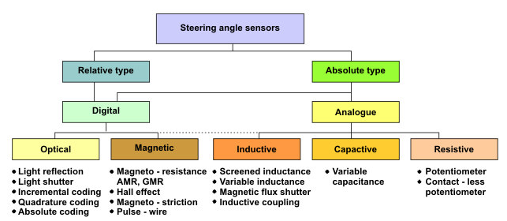

Figure 9 Steering Angle Classification

Depending on the application, steering angle sensors can be attached in different configurations. The typical configuration involves a steering sensor located on a steering column as shown in

Figure 10.

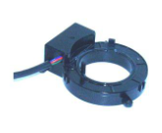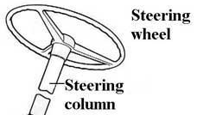

Figure 10 Steering Wheel Sensor Example

There exist different configurations in which the rotation of the steering wheel is converted into an electrical signal. In general most of them works through the principle of a “disturbance” which causes an electric signal output. This disturbance is expressed in changes of: magnetic fields, capacitance, inductance, resistance and optics. This principle is illustrated on Figure 11 where a sensor is placed in a geared steering column, causing changes in the signal due to the disturbance generated due to bigger air gaps in between the sensor and the gear.

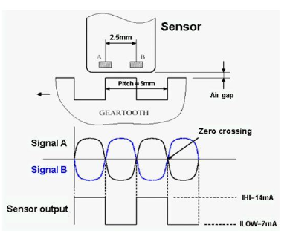

Figure 11 Steering Wheel Basic Measurement Principle

Once the disturbance causes an electric signal output, the interface can be either Controller Area Network (CAN), Local Interconnected Network (LIN), digital or analog. Steering Wheel Sensors vary with operating principle and location. Thus, Table 3 Specifications for Steering Wheel Angles offers a summary of the general specifications of a Steering Wheel Angles based on its location.

Table 3 Specifications for Steering Wheel Angles

|  |  |  |  |
| --- | --- | --- | --- |
|  | Operating Temperatures | Resolution | Max. Angular Error |
| Steering Wheel | -40 C to 85 C | 0.1 to 2 | 2.5 |
| Steering Column | -40 C to 85 C | 0.1 to 2.5 | 3.5 |
| EPS Column | -40 C to 125 C | 0.1 to 1.5 | 2.5 |

As it was previously described, the operating principle in steering sensors can come in different types such as Magnetic, Inductive and Resistive, so that their working principle will be explained in detail.

* + - 1. Magnetostatic Sensor

Magnetostatic sensors subdivide in two branches: galvanomagnetic effect and magnetoresistive effect sensors. The difference in between them is that galvanomagnetic is closely related to temperature changes from external magnetic fields, and magnetoresistive effects refer to the tendency of changing resistance with an external magnetic field. The magnetic fields generated also can penetrate through most plastic and non-ferromagnetic metals. Both methods use a direct current to alternate magnetic fields within the sensor and record voltage drop measurement. Research is still developing new techniques to analyze and obtain better mathematical relations from these effects [69]. Advantages of those sensor are easy encapsulation for protection, and easy to miniaturize.Some disadvantages are that parts are sensitive to impacts or high vibrations.

* + - 1. Hall Sensor

This sensor is a magnetostatic sensor that uses galvanomagnetic effects. This sensor operates by using an inducted magnetic field going through a thin semiconductor-chip as shown in Figure 12. The inducted magnetic field creates a charge deflection by Lorentz forces. This deflection creates a current which is proportional to the voltage applied. The relationship in between the parameters is shown with the following formula:

Where:

= Chip Thickness (m)

H = Magnetic Field (T)

= Hall Coefficient (m3/A-sec)

I = Current (A)

The advantages of Hall Sensors include cheap production as they use silicon for circuit channels. Some disadvantages are thatcost can be proportional to signal-conditioning efficiency and circuit integrations. Also, higher temperature usage and force resistance will increase cost. There is a high variety of applications for Hall Sensors. Some include position sensing for transmission control, which are used to identify gearshifts. Another use is the axle sensor which can sense the body’s inclination angle, which is measured through compressions on rotary levers.

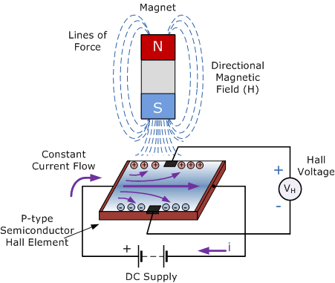

Figure 12 Hall Effect for Measurement

* + - 1. Magnetically Inductive Sensor

Magnetically Inductive Sensor measure using the principle of eddy-currents. They have a magnetic disk that is at a set distance to an electric metal coil as shown in Figure 13. Like Hall Effect sensors, changes in the magnetic fields will cause a voltage drop. This voltage drop causes changes in both inductance and resistance that are used to obtain the desired measurement. The mathematical relation is expressed through Faraday’s Law of Induction as follows:

Where:

= Number of Coils

= Cross-Sectional Area (m2)

= Magnetic Flux (as a function of Length and Current) Wb or Volts-Sec

Some advantages are performing non-contact position measurement with minimum interference and while being a robust sensor. Disadvantages are that compared to other micromechanical sensors, coil configurations occupy a fair amount of space. Different applications include position sensing for transmission control which utilizes the eddy-current created in between a sensor board and a rotor. The geometry of the rotor has a cyclically varying configuration which can provide a continuous variable sensing during the transmission control.

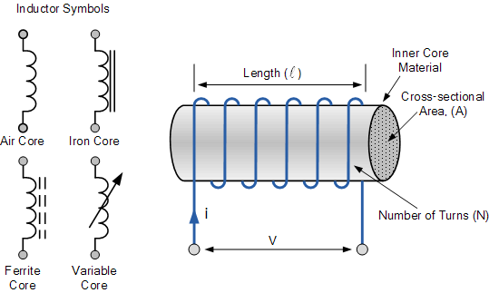

Figure 13. Magnetically Inductive Sensor Approach

* + - 1. Potentiometer

This sensor measures travel by using a proportional relationship in between the length of a wire or film resistor and its electrical resistance. From Figure 14, the major components are defined as a wiper, a resistive material, and connection pins. A wiper goes through the resistive material creating changes in electrical resistance. By moving the wiper to the left, the resistance between the middle and left pin decreases while the middle and right increases. For the wiper moving to the right, the opposite is true.

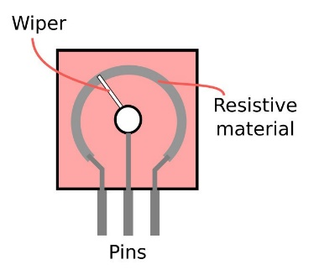

Figure 14. Depiction of a typical wiper potentiometer

The basic mathematical principle for potentiometers comes from Ohm’s Law:

Where:

Voltage (V)

Current (A)

Resistance (which is inversely proportional to length) (Ohms)

One main advantage is an operating temperature ranging up to 250 degrees Celsius while having a high degree of accuracy. Disadvantages include, abrasion wear, wiper lift-off due to vibrations and measurement errors due to the wear and vibration factors. Applications include an accelerator-pedal sensor which is the main sensor which detects the travel angle for the accelerator pedal. Then this value can be interpreted as an increase throttle request for control algorithms. Some other applications include throttle-valve angle sensors and fuel-level sensors.

* + 1. Vehicle Wheel Speeds/ RPMs

Wheel Speeds play a crucial role in autonomous vehicle development for Anti-Lock Braking Systems by measuring in time wheel speeds to make braking decisions, whereas Revolution per Minute (RPM) play a role in the diagnostics of vehicle performance such as crank-shaft rotations. A typical speed sensor in located in the shaft connected to the wheel rotor as shown in Figure 15.

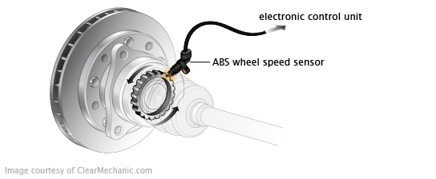

Figure 15 Wheel Speed Sensor Location

The basic working principle works the same as steering wheel sensors described in Figure 11, but for higher speed rotations. Since these types of sensors need to handle considerably faster signal changes than Steering Wheel Angles Sensors, not all measurements from Steering Wheel sensors are applicable. For high speed applications, sensors are divided in two main sections: Magnetic Sensors and Tachometers.

* + - 1. Magnetic Sensors

Magnetic effects include both Hall Effect and Magnetoresistive Effects. These work under the same principle as in Steering Wheels, but their operating rates can go considerably faster levels than typical Steering Wheel applications. These types of effects need a current provided from a voltage source (from the ECU) to operate, thus are named active sensors. On high speed operations, the use of speed sensors can be passive which means no external power source is needed. The principle works by attaching a variable reluctance sensor to a high rotation element. The magnetic attraction in between the sensor and the rotating element changes as the speed increases. When the velocity goes high enough, a magnetic field is generated without the use of voltage or current. When this occurs, the variable reluctance sensor records the changes in the magnetic field and sends them to the ECU as an electrical signal output. For the given magnetic sensors, the following are the typical operating conditions:

* Power Supply (Only on Active Wheel-Speed Sensors)
  + 5 V Regulated Voltage from ECU
  + 12 V Battery Supply with Protection in the ECU
* Operating Temperature for Magnetic Sensors at High Speeds
  + -40 C to 150 C
    - 1. Tachometer

Tachometers in vehicles are typically used to monitor engine RPM. This is done by measuring the rotational speed of the engine shaft. The speed of the shaft is measured with encoders or a mark on the outer diameter of the shaft. Whenever a revolution is completed, the mark will be detected by an encoder, and a pulse is sent. It can also be measured by tracking the voltage pulses to the engine ignition system which is proportional to the engine speed. The working principle involves Faraday’s Law of Induction (Equation 2) as it was previously described, but the arrangement of coils and magnets manages higher speed outputs as it is shown in Figure 16.

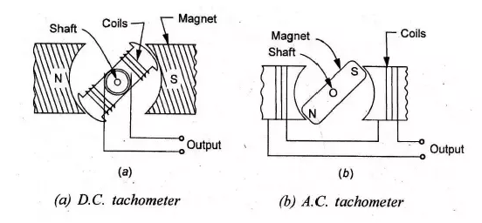

Figure 16 Tachometer Types

The typical disadvantage is that operational temperature is limited to over a temperature range of -20 to 70 C which can be sometimes undesired. The use of tachometers enables the driver to prevent exceeding speed capacity of many parts. Thus, preventing overheating, unnecessary wear or permanent damage.

* + 1. Vehicle Angular Rates

Angular Rates is a parameter that is being used for autonomous applications mainly to predict and control vehicle’s heading angle. Angular Rates refer to the rate of rotation about a specific axis. In spatial coordinates, the Agular Rate refers to the change in pitch, roll and yaw (or rotation about x, y, and z axis). Angular Rates are measured by sensors known as gyroscopes as shown in Figure 17.

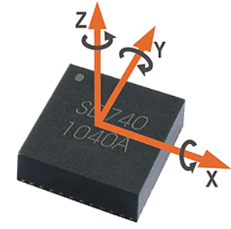

Figure 17 Example of Gyroscope and Axis of Rotation

* + - 1. Gyrometers

The working principles for Gyroscope involve the Coriolis Effect and the Conservation of Momentum [73]. Assuming a mass m under simple harmonic motion in the X-Direction described by:

Has a mathematical formula that drives the Coriolis effect is

Combining (4) and (5) yielding:

Where:

= Displacement (mm)

Amplitude (mm)

Time (sec)

Angular Velocity in the Perpendicular Direction (rad/sec)

Driving Frequency of Vibration (rad/sec)

Coriolis Acceleration (mm/s2)

Assuming a concentrated mass m, the effect of Coriolis Accelerations is investigated through a mass spring damper model as shown in Figure 18. The induced vibration on the X-Direction will generate a perpendicular acceleration on the Y-Axis due to Coriolis Effect along with a rotational component in the Z-Direction. This rotational velocity on the Z-Axis labeled as H on Figure 18 gets counterbalanced by Conservation of Momentum where a new rotation labeled as M is created.

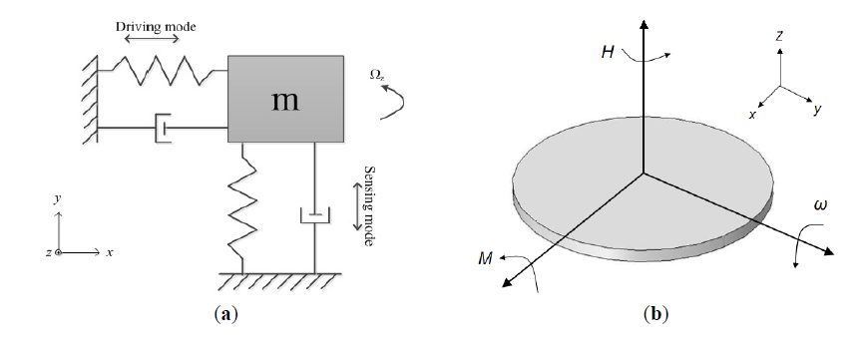

Figure 18 Gyroscope Mechanical Model Extracted from [73]

The spring-mass-damper model contains springs and damper made of resistive materials that along with a capacitor will create a voltage drop as the orientation of the disk changes.

* + 1. Vehicle Accelerations

Accelerations are primarily measured in vehicles to have a trigger on airbag deployment, but have been used in autonomous driving technology as well. Some of these uses include measuring vibration in mechanical parts, and inertial navigation systems. As the name suggests, accelerations are measured with accelerometers Technology for acceleration measurements is being focused on miniaturization without losing reliability. As it is shown in Figure 19, both accelerometers shown differ considerably in size but offer a similar reliability in signal information. Differing from other driving parameters, acceleration measurements are mostly performed with the same working principle which is used in most accelerometers.

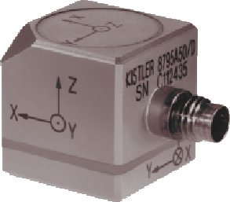 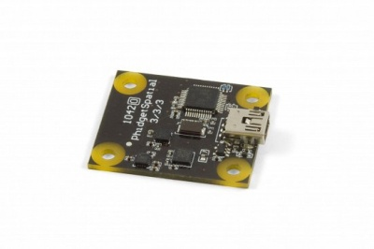

Figure 19 Accelerometers Comparison

* + - 1. Accelerometers

The working principle of accelerometers is Newton’s 2nd Law of Motion which stats:

Where:

Sum of Forces Applied to an Object (nN)

Mass of the Object (mg)

Acceleration of Object (mm/s2)

Equation 7 is mainly valid for point or concentrated mass. For this reason, new Micro-Electro-Mechanical Sensors (MEMS) use masses small enough to increase the precision of measurements while satisfying the condition to apply Equation 7. Similar to Gyrometers, Accelerometers can be represented by a spring-mass system as shown in Figure 20:

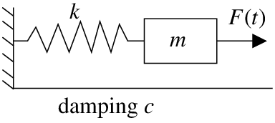

Figure 20 Mass-Spring System with Input Force

For this situation, Equation 7 becomes a summation of forces in the horizontal direction:

Where

= Input Force (nN)

Stiffness of spring

Spring Contraction or Mass Displacement (mm)

Acceleration (mm/s2)

Mass of the Object (mg)

Based on Equation 8, there is a direct relationship from the input forces and the acceleration, which can be calculated by knowing the stiffness of the spring. For MEMS, capacitors are used instead of springs which record a voltage reading after a certain displacement. From there, acceleration can be directly obtained from accelerometers. An example of this concept is offered in Figure 21 where instead of measuring displacements, a capacitance change occurs due to the movement of the fingers which represent the mass.

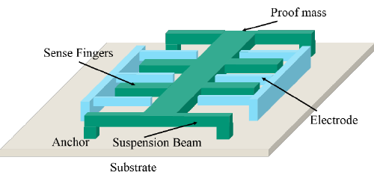

Figure 21 Accelerometer Measurement Concept

There are differences in accuracy and sensitivity which is based off material/design/manufacturing of the sensor. For accelerometers, the following specifications are taken into account:

* Sensitivity
  + Rollover Detection/Tilt Detection/Anti-Lock Brake System + 1.5, +5, and +10 g’s
  + Crash Sensing + 40, +50, +70, and +100 g’s
  + Contact Accelerometers at Anticipated Point of Impact on Side/Front + 250 g’s
* Recommended Operational Bandwidth Frequency
  + Impact Applications 400 Hz
  + Normal Applications 50 Hz
* Operating Temperatures
  + -40 C to 125 C
* Operating Voltages
  + 2.7 – 6.0 V DC
    1. Vehicle Environment Recognition

In the world of autonomous vehicles, detecting the surroundings is a vital part of safely navigating its environment. In order for the vehicle to detect its surroundings it makes use of a variety of sensors, most commonly lidar, radar, ultrasonic sensors, and video cameras. Current environment recognition technologies have a wide scope of aims. Many methods look to locate the relative position of surrounding objects. While others work to identify specific objects like road markings and signs or pedestrian and vehicles.

The process of environmental detection is very similar across the wide spectrum of sensors. The process begins with the collection of data whether that be from radar, video cameras, or lidar. The data is then processed and filtered so the data set is crisper so it better represents the surrounding environment. One of the main focuses of the processing is to define object boarders so they can be classified. Once the objects are defined they are compared against defined object parameters and features to detect what the object is. Once the object is correctly identified the data is used in additional analysis, so it is can be used in the vehicle whether it is for lane detection, sign identification, or collision avoidance. This is an extraordinary complex procedure and there are many potential errors. If the objects are not detected or classified incorrectly it can have severe consequences. For example, if a pedestrian is not identified as such the vehicle will take no action to avoid them. Each sensor constructs the virtual vehicle environment in different and therefore each is more affected by different factors.

* + - 1. Radar Sensors

Radio Detection And Ranging (or simply Radar) sensors emit electromagnetic waves and record time-of-flight (TOF) to reflect off the environment and return to an observer Radar Range can be calculated through the following formula:

Where:

= Transmitted Power (W)

= Antenna Gain

= Antenna Effective Aperture (m2)

= Radar Cross Section of Target (m2)

= Minimum Detectable Signal (W)

Radar at normal conditions use the Doppler Effect to accurately measure speeds. The Doppler Effect is the difference in between an observed frequency and an emitted frequency relative to the source of the waves. This can be illustrated with the following formula:

Where:

Observer’s Frequency (Hz)

Source Frequency (Hz)

Speed of Light (m/s2)

Observer’s Velocity (m/s)

Source’s Velocity (m/s)

From Equation 10, some inferences can be made. First, the Doppler Effect is affected by the medium in which the waves are traveling. Because the speed of light is approximately constant in air, distances can be calculated from TOF. Second, since the effect is calculated from bouncing of waves, material properties affect the degree of effectiveness for radars. Within the same scope, clutter echoes coming from weather environments (such as hail, rain snow) tend to interfere with the radar waves because they create constructive or destructive interference of wave with the observer’s frequency (Equation 10). When this occurs, received signals by the radar might be higher or lower than the true wave which creates inaccurate predictions for object positioning and recognition. Another flaw with radar is that due to its relatively low wave frequency, it has the potential to pass through some objects rather than rebound back to the sensor. Due to this, when using radar, a variety of them are typically placed around the vehicle

Radar is used for systems like blind spot warning, ACC, and FCW, in which there are different ranges of radar used. For example, long distance radar is used for front end and automatic cruise control as the vehicle needs to sense the vehicle far enough ahead to have enough time to react. While short range radar is used to detect vehicles in the host vehicle’s blind spot and other close-range situations. Examples of long and medium radar sensors can be seen in Short- and Long-Range Radar are used to measure distances between coordinates (X1 – X2) and (Y1 – Y2), respectively. Short-Range Radar Systems uses Continuous Waves (CW) only. Long-Range Radar uses Frequency Modulated Continuous Waves (FMCW) which can modulate transmission frequency for variable distance determination. Some radar measurements are only possible by changing frequency during runtime. For example, measuring target range and relative velocity at the same time is only possible in FMCW radar and not in CW radar. Both utilize the Doppler Effect to calculate vehicle positions.

The following are the specifications for both Radar Types and their common characteristics:

FMCW Radar

* Operational Frequency
  + 76.5 GHz
* Range of Distance and Accuracy
  + 2 m to 250 m with + 3 cm

CW Radar

* Operational Frequency
  + 24 GHz
* Range of Distance and Accuracy
  + 20 cm to 20 m with + 3 cm

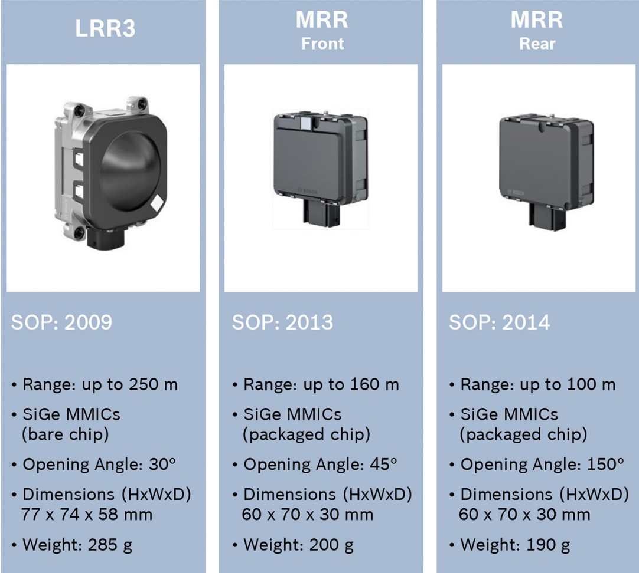

Figure 22 Radar Sensor and Specifications manufactured by BOSCH [75]

Finally, Radar is not able to distinguish one object from another so vehicles cannot rely only on it to make intelligent decisions. It also has a limited field of view as there is trade-off between range and field of view. The longer the range of the sensor the smaller the degree of view [75]. Additionally due Radar has the potential to pass through objects rather than rebound back to the sensor. As a result, it must be used in conjunction with other sensors to control an autonomous vehicle.

* + - 1. Ultrasonic Sensors

Another sensor that can be used in modern vehicles is an ultrasonic sensor. An ultrasonic senor used in vehicles can be seen in Figure 23. The working principle is similar to Radar, where a sound wave is emitted into an environment that is reflected off objects and sent back to the sensor. The main difference is that ultrasonic sensors operate using a different signal. Ultrasonic sensors also have a much smaller range of only a few meters [36]. Therefore, these sensors are used to detect objects near vehicles. They are typically used in low-speed scenarios like parking assist systems [37].

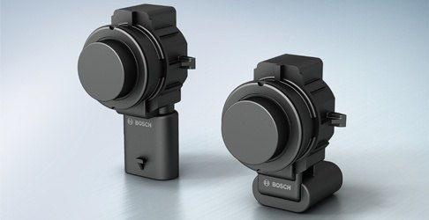

Figure 23 Ultrasonic Sensor used in vehicle manufactured by BOSCH

Similar to Radar, ultrasonic sensors are only good for proximity sensing and distance measurement and cannot distinguish one object from another. Another flaw with ultrasonic is that some materials are sound absorbent making them invisible to the sensor. Additionally, some other materials that are partially sound absorbent will obscure the distance measurement can lead to errors. These sensors can also be influenced by other factors like ambient noise, humidity, and temperature [36].

* + - 1. Lidar

Lidar is a sensing system that is used by many autonomous vehicle developers. Typically, lidar sensor is used and placed on the top of the vehicle. This allows the sensor to view a 360º area around the entire vehicle. Examples of lidar sensors can be seen in Figure 24. Lidar uses a laser to scan the vehicle surroundings. This data is then compiled to make a point cloud of the placement of all the objects around the vehicle. This makes a digital map of the surroundings of the entire vehicle. Then the system works to classify the objects in the environment. Two different methods are used together to help detect objects. First each object seen by the optical laser gives off a certain intensity upon its return based on its surface finish. This characteristic can be used to detect a potential object. The next method is using the entire object shape and based on unique object profiles, like height and length, the sensor is able to determine the identity of the object [12]. For example, the unique curvature and profile of vehicles is used to detect them on the road.

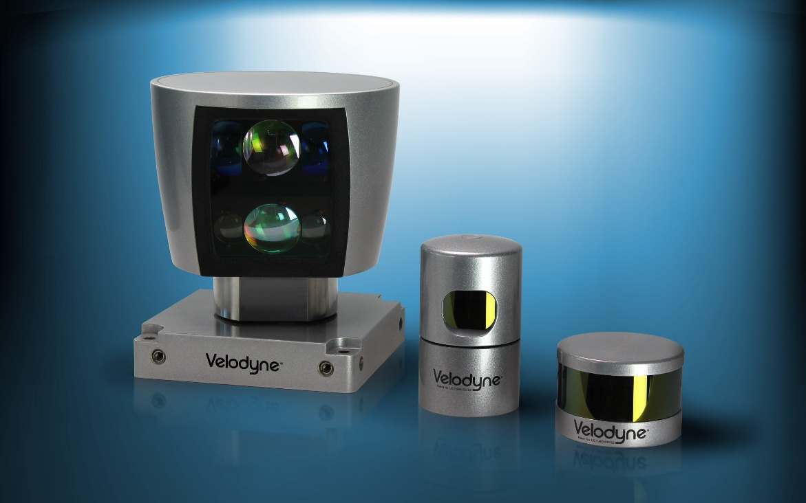

Figure 24 Examples of Lidar Sensors as manufactured by Velodyne

Infrared radiation is emitted from this sensor which is reflected by objects to identify them. This sensor is divided in two main versions, namely, Pulse Lidar and Continuous Wave Lidar. The principle is similar to Radar where a signal is emitted and then received to calculate phase differences and time propagation. Under clear conditions, Lidar can provide high accuracy (5 to 15 cm) in the distance measurement of objects. Standard measurement range of operation is 150 to 250 m.

Lidar sensors are an excellent tool for interpreting the vehicle space being able to create a virtual map. However, there are some major pitfalls with the system. The sensor is able gather a lot of data around the vehicle but only in the clear and controlled environments. If there is any significant particle accumulation in the air in the form of dust, rain, or snow the laser will reflect off these instead of reaching the important objects. This poses a major problem given that a lidar-controlled vehicle fleet could not be used unless the conditions are ideal. Additionally, if anything gets on the sensor itself it will also obstruct the sensor which can be a common occurrence since it is typically exposed on the top of the vehicle.

As it would be expected, environmental recognition is a vital process for a self-driving vehicle. These systems are the only interpretation the vehicle has of the outside world and therefore the basis for all its decision making. Errors in environmental detection have serious and fatal consequences. Each sensor has different advantages and they are often all used in conjunction with one another to encompass as much as possible. However, using all of this sensing hardware is costly for commercial use. Even with using a multitude of different sensors, gaps still exist in data even in ideal conditions.

* + - 1. Video Sensors

This sensor works under the principle of photosensing. The principle of photosensing is that photons shine in a semiconductor, generating electrons, which have a charge and an electric field. Then, a photoelectric current is generated to measure the light intensity in the form of voltage. Different semiconductors provide different contrast or intensity for the video sensor. The most used are the photodiode and metal-oxide semiconductor capacitor (MOS capacitor). MOS capacitors have two variations which are charge-coupled devices (CCD sensors) and CMOS sensor technology. Each type of sensor has different advantages, for example CMOS sensors require less energy to operate than CCD sensors. CCD pixels are read serially whereas on CCD these are read out in a matrix structure. Despite different efficiency differences, the main disadvantage of these sensors is that they are susceptible to extreme weather conditions and also image identification problems. For example, video sensors can detect foreign objects, but they cannot determine the degree of danger involved. The primary use of video sensors include image processing, object recognition and many sub-categories of those. Such as pedestrian, vehicle or road sign recognitions.

Video cameras are very inexpensive especially compared to the other vehicle environment sensors. Cameras are a great recognition tool because they like humans they see the world in the optical spectrum. This allows us to use the things that we can see to program the camera to distinguish different objects. However unlike humans cameras to not see in three dimensions, in fact without any context the visual images are dimensionless to a computer. This is what separates the two main modes of visual recognition, monocular vision and stereo vision.

Monocular vision uses just a single camera while stereo vision uses two camera set up in parallel. A stereo camera configuration can be seen in Figure 25 .Stereo vision allows two images of the same object to be collected. The two objects undergo the process of image rectification. In this process the images are compared with one another and the similar pixels are matched up horizontally. Then by using the distance between the two cameras, the cameras’ focal point, the disparity between the two images is used to dimension the objects in the frame. In this way the camera system can tell the relative size of objects and the distance they are away [10]. The next step is to classify the objects in the image.

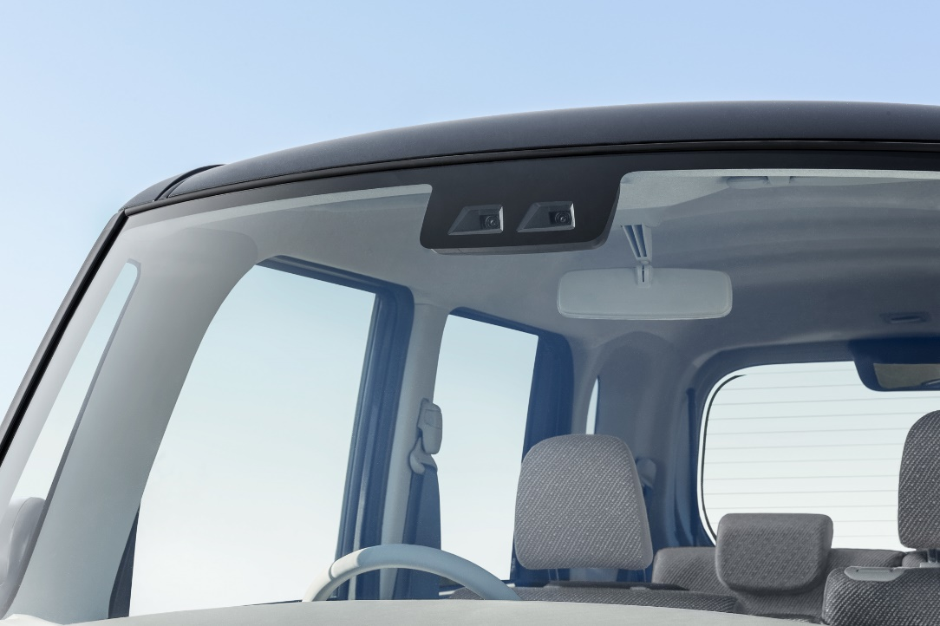

Figure 25 Stereo Vision Sensor manufactured by DENSO

Both monocular vision and stereo vision work using similar processes to classify objects. One method is done by motion recognition. Motion recognition is typically used to locate vehicles. The camera tracks the pixels in the images by comparing it with the previous frames. Since the surrounding vehicle will have relatively the same speed as the host vehicle, the vehicle pixels will stay in frame for much longer time period than the surroundings. This method also helps to filter out false positives. If a vehicle suddenly pops up out of nowhere instead of gradually coming into frame as a normal vehicle it can be determined to be a false reading. The other method of object classification is appearance recognition. The pixel patterns are analyzed for specific characteristics. A histogram of oriented gradients (HOG) is one of the methods used to define the edges of potential objects. It works by calculating the gradient of the color intensity in the image. Typically the background intensity is lower and the intensity increases at the edges of an object as they are made up of more definitive color schemes. This defines the relative shape of the objects which can be used to classify them. This method is particularly useful in road sign detection as they have very sharp edges with sharp contrast the rest of their surroundings and some signs have different shape which simplifies the identification process. However this method in particular is very computationally expensive [13]. Another method is to identify objects using Haar-like features. The principle behind this is using typical pixel color patterns specific to certain objects. For example the front of vehicles can be defined by the clear headlights and windshield and the side has the circular tires and uniquely shaped windows [11].

However image recognition is not a perfect system and there are many things that can cause issues. First and foremost image recognition using pixel images is a very computationally expensive undertaking. This can be solved by reducing the resolution of the camera, but too little resolution will yield additional errors. Lighting also can play a significant roll especially when attempting to dimension an image as shadows disrupt the process. Additionally detecting certain objects at night is a challenge as the lighting has very stark changes. However, high dynamic cameras can help as they are able to see more in low light scenarios. Another major issue with optical detection is seeing false positives. There are many instances where the background can exhibit the characteristics of vehicles and other road objects. Cameras also have a limited field of view and wide angle cameras suffer from a fisheye effect. However more cameras can be used to help mitigate these issues since they are relatively inexpensive.

* + - 1. Video Sensors

This sensor works under the principle of photosensing. The principle of photosensing is that photons shine in a semiconductor, generating electrons, which have a charge and an electric field. Then, a photoelectric current is generated to measure the light intensity in the form of voltage. Different semiconductors provide different contrast or intensity for the video sensor. The most used are the photodiode and metal-oxide semiconductor capacitor (MOS capacitor). MOS capacitors have two variations which are charge-coupled devices (CCD sensors) and CMOS sensor technology. Each type of sensor has different advantages, for example CMOS sensors require less energy to operate than CCD sensors. CCD pixels are read serially whereas on CCD these are read out in a matrix structure. Despite different efficiency differences, the main disadvantage of these sensors is that they are susceptible to extreme weather conditions and also image identification problems. For example, video sensors can detect foreign objects, but they cannot determine the degree of danger involved. The primary use of video sensors include image processing, object recognition and many sub-categories of those. Such as pedestrian, vehicle or road sign recognitions.

Video cameras are very inexpensive especially compared to the other vehicle environment sensors. Cameras are a great recognition tool because they like humans they see the world in the optical spectrum. This allows us to use the things that we can see to program the camera to distinguish different objects. However unlike humans cameras to not see in three dimensions, in fact without any context the visual images are dimensionless to a computer. This is what separates the two main modes of visual recognition, monocular vision and stereo vision.

Monocular vision uses just a single camera while stereo vision uses two camera set up in parallel. Stereo vision allows two images of the same object to be collected. The two objects undergo the process of image rectification. In this process the images are compared with one another and the similar pixels are matched up horizontally. Then by using the distance between the two cameras, the cameras’ focal point, the disparity between the two images is used to dimension the objects in the frame. In this way the camera system can tell the relative size of objects and the distance they are away [10]. The next step is to classify the objects in the image.

Both monocular vision and stereo vision work using similar processes to classify objects. One method is done by motion recognition. Motion recognition is typically used to locate vehicles. The camera tracks the pixels in the images by comparing it with the previous frames. Since the surrounding vehicle will have relatively the same speed as the host vehicle, the vehicle pixels will stay in frame for much longer time period than the surroundings. This method also helps to filter out false positives. If a vehicle suddenly pops up out of nowhere instead of gradually coming into frame as a normal vehicle it can be determined to be a false reading. The other method of object classification is appearance recognition. The pixel patterns are analyzed for specific characteristics. A histogram of oriented gradients (HOG) is one of the methods used to define the edges of potential objects. It works by calculating the gradient of the color intensity in the image. Typically the background intensity is lower and the intensity increases at the edges of an object as they are made up of more definitive color schemes. This defines the relative shape of the objects which can be used to classify them. This method is particularly useful in road sign detection as they have very sharp edges with sharp contrast the rest of their surroundings and some signs have different shape which simplifies the identification process. However this method in particular is very computationally expensive [13]. Another method is to identify objects using Haar-like features. The principle behind this is using typical pixel color patterns specific to certain objects. For example the front of vehicles can be defined by the clear headlights and windshield and the side has the circular tires and uniquely shaped windows [11].

However image recognition is not a perfect system and there are many things that can cause issues. First and foremost image recognition using pixel images is a very computationally expensive undertaking. This can be solved by reducing the resolution of the camera, but too little resolution will yield additional errors. Lighting also can play a significant roll especially when attempting to dimension an image as shadows disrupt the process. Additionally detecting certain objects at night is a challenge as the lighting has very stark changes. However, high dynamic cameras can help as they are able to see more in low light scenarios. Another major issue with optical detection is seeing false positives. There are many instances where the background can exhibit the characteristics of vehicles and other road objects. Cameras also have a limited field of view and wide angle cameras suffer from a fisheye effect. However more cameras can be used to help mitigate these issues since they are relatively inexpensive.

* + 1. Machine Learning

Video sensors themselves are not enough to identify objects. For this reason Machine Learning is used for object identification. Machine Learning consists of writing algorithms that use data information obtained from sensors to let the computer make classification decisions. The subject of Machine Learning is subdivided in three broad categories:

Supervised Learning: The data is obtained and the desired output is known. This process utilizes the concept of regression. In Supervised Learning, there exists many regression algorithms to make decisions.

Unsupervised Learning: The data is obtained, but the desired output is not known. For this process, clustering is used in order to find patterns that can serve to classify and add meaning to data.

Reinforcement Learning: The data is obtained, but the desired output is affected by the influence of random variables. For this, program attempts trial and error to achieve an output.

All these categories often follow a similar approach. In Autonomous Vehicles, all these types of learning algorithms have primarily used in object recognition. To illustrate the basic concept of machine learning, the structure for Supervised Learning is as follows:

1. Obtain a data set of an independent variable x, and dependent variable y
2. Choose a function that can relate both variables, such as linear function

Where:

Prediction Function

Polynomial Constant

Independent Variable from Data Set

This equation is a mathematical model that can make predictions h(x) based on a given input variable x. Note that this equation can be linear, non-linear, and have as many constants needed depending on the nature of the problem to solve.

1. Obtain a Cost Function which represents a value that can be minimized to obtain a result. Since the objective for Supervised Learning is to make predictions of a known output, difference of square errors is an example of an efficient Cost Function:

Where:

Prediction Variable

Cost Function

Independent Variable from Data Set

Number of Data Points from y

Note that this step can use different Cost Functions that describe the relationship in between the Prediction function and the independent variables.

1. Minimize the Cost Function. This process usually uses an algorithm known as Gradient Descent which is based from the idea of Optimization in Calculus:

Where:

Current Constant to be minimized

Cost Function

Learning Rate

Equation 3 is iterated until convergence is achieved. In this case, the learning rate is a “leverage” constant that can make the algorithm to converge faster or slower. Sometimes, choosing an incorrect learning rate can lead to divergence of the algorithm. Note that Gradient Descent is not the only minimizing algorithm for the cost function.

After the previous steps have been followed, the Gradient Descent Algorithm will converge into final values for the coefficients from the Prediction Function (Equation 11). This final equation would then be able to predict future values y based on its training set. An example of an optimized Prediction Function through Gradient Descent is shown in Figure 26.



Figure Optimized Prediction Function through Gradient Descent.

* + 1. Vehicle GPS Sensor Location

Vehicle navigation is a vital part of increasing the level of autonomy in vehicles. Smart vehicles must be aware of their current locations and proximities to hazards at all times. For a vehicle to navigate the road, it needs to know what lane of the road it is on, how close it is to the lane edges and how the road changes to be able to finely adjust its trajectory.

Global positioning systems (GPS) can be a vital part of locating a vehicle. GPS uses a series of satellites and pseudo random code time-to-return in order to triangulate latitude and longitude on earth. However this location is subject to uncertainty, and commercial grade GPS systems are rarely accurate to less than one meter [19]. Precision errors could cause vehicles guided by GPS to wander on the road.

A GPS system can be supplemented with a real time kinematic (RTK) or a differential GPS (DGPS) to improve accuracy. Both of these technologies an additional base station which remains static. The static base station develops a time history of GPS coordinates and exactly determines its own location. Then, the base station sends a reference set of static GPS coordinates for the DGPS correction, or establishes a secondary, direct contact with the vehicle for a RTK solution.

A DGPS and RTK system can help locate a GPS position of up to a couple of centimeters however the user must be in a 20 – 25 mile range of the base station to get this accuracy [20]. This accuracy is precise enough to accurately locate a vehicle on the road, but requires that vehicle always be within range of the base station. Additionally, base stations are currently very expensive which poses a financial hurdle.

Another GPS system addition that helps to increase the accuracy is the addition an inertial measurement unit (IMU). An IMU is a sensors that uses accelerometers and gyroscopes to interpret the current motion of the vehicle. The IMU is often used to help improve GPS location using the process called dead reckoning (DR). DR uses the IMU to estimate the future vehicle position for a predicted trajectory based on its current acceleration and velocity. It then compares this estimated position with the GPS position to obtain a more accurate vehicle location. The system also helps to fill in gaps when GPS signal is momentarily interrupted or lost. One of the main drawbacks of this system is that when error occurs in the system that error can accumulate instead of correcting itself placing the vehicle in the wrong position, for example the wrong lane.

Another option to help localize the vehicle is to use environmental recognition to localize the vehicle. Using the environmental recognition systems discussed previously the surrounding are used to help the vehicle know where on the road it is located. Various external vehicle sensors like cameras, lidar, and radar are used to calculate the distance to surrounding road designators which locates the vehicle within its particular lane. It is coupled with the GPS system to get its relative position. For example the lane detection is used to position the vehicle within the lane. Additional aids like landmarks and waypoints can be used detect the lane edges [21]. The major benefit of this system is that it continues to work even when GPS isn’t reliable, however it is still affected by the environment.

Overall, GPS is a great tool for vehicle navigation but it must be coupled with other systems in order to achieve the necessary accuracy to locate the vehicle on a particular place on the road. However, GPS itself has been shown to be unreliable in dense urban areas with tall building and in tunnels when a constant signal cannot be found. Other systems can help bridge this gap by predicting future motion and survey the vehicle surroundings, but are subject to limitations as well.

1. DATA FILTERS

Sensors take signal information from the environment to communicate it to the vehicle ECU. Both signal information and outputs are susceptible to noise which is unnecessary information about the signal being analyzed. Therefore filtering techniques are used to remove this noise. Filters use a threshold frequency in which frequencies get attenuated and then modify their output signal. In general, filters can be classified by overlapping parameters, which include:

* Linear/Non-Linear
  + Which refers to the type of mathematical model that describes the behavior of the signal
* Time-Invariant/Time-Variant
  + Which refers to the dependence signals can have with respect to time.
  + In Time-Invariant systems, a delayed input signal always produces the same delayed output signal.
* Discrete/Continuous
  + In which continuous data is in the form a mathematical model represented by a continuous smooth signal and do not contain instantaneous changes or breaks.
  + In which discrete refers to scatter data points that are not connected.
* Analog/Digital
  + Refers to a type of electric signal sent to the filter.
  + For Analog electrical signals, they follow a continuous pattern.
  + For Digital electrical signals, they follow a discrete pattern.

Overall, autonomous vehicle technologies contain different types of filters depending on the application. In this chapter, some of the commonly used filters are discussed.

* 1. Kalman Filter

This filter is based on a recursive mathematical models that is represented by linear differential equations. These models use state variables which represent a physical parameter on the system. Kalman Filters work by creating vectors of state variables that will predict the system at a future time. These predictions will be modified by the Kalman Gain and measurements corrections from the sensors. The typical summary layout of a Kalman Filter is shown in Figure 27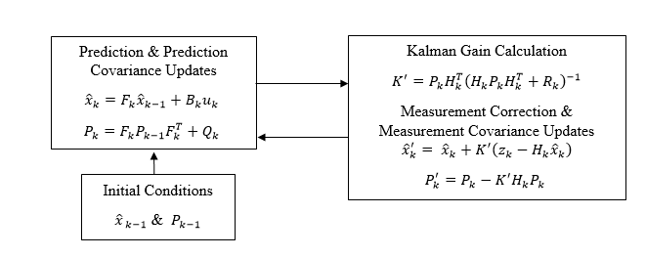

Figure 27. Kalman Filter Iterative Procedure [24]

Equations describing the state variables of a system in matrix form is known as state space representation. The first equation of the Kalman Filter is developed as follows:

Where:

Current State Vector or Physical Parameters of Interest

Dynamic Matrix with Mathematical Constants used to describe the State Variables in the Physical System

Previous State Vector

Control Matrix with Mathematical Constants used to describe External Influences

External Influences Vector

In ACC context, the Dynamic Matrix represent physical equations that describe the evolution of state variables which can be position and velocity as a function of time. The Control Matrix represents a control system such as throttling or braking, which is affected by the External Influence which can be a force input by the driver.

Along with state variables (or simply states), this filter utilizes the probability distribution of each them and combines them linearly to filter out information. When this occurs, the variance of each probability distributions is lumped together into a single variance which reduces the number of variances involved in the estimation of a future state. This probability combination is shown in Figure 28.

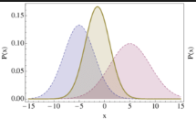

Figure 28 Combination of Gaussian Probability Distributions

Since Gaussian Distributions can be added, it is possible to measure the variability of them as long as they are random. This is done through the Covariance Matrix associated with states being used. This Covariance Matrix can also be updated with new iterations as follows:

Where

Covariance Matrix (Relation in Between 2 or more Random Variables)

Dynamic Matrix with Mathematical Constants used to describe the State Variables in the Physical System

Previous Covariance Matrix

Process Noise Uncertainty Matrix from Environment

In the ACC applications, this process noise can be the considerations of high wind speeds during driving which delay vehicle travel. This uncertainty matrix may be zero for random noise with no external factors. Following Figure 27, State Predictions along with Predictions Covariance are updated. Then the next step is to develop a relationship in between the Predictions and the Measurements. Which is shown in the following equation:

Where

Optimized State Vector

Current State Vector

Kalman Gain

State Measurements from Sensors

Sensor Matrix with Mathematical Constants used to describe External Sensors

This equation takes the predicted states and adds two new factors from sensor measurements to develop an “optimal prediction”. Similarly to the States Covariance, there is a relationship in between random variables in the sensor. For this reason the Kalman Gain was developed to find a relationship of covariance for both states and measurements. The Kalman Gain is described as follows:

Where the parameters have been previously defined in Equations 2 and 3.

Through this Kalman Gain, it is possible to add a correction to the covariance calculated in Equation (16) and create a new “optimal prediction update” in the following form:

With the Kalman Gain defined and an optimal prediction of states, the Kalman Filter iterates the process of obtaining new state variables based on the physical description and measurements of the system. Mathematical derivations and in-depth explanation of the Kalman Filters can be found on [24].

* 1. Extended Kalman Filter

This filter is based on non-linear mathematical models that can be modeled at discrete times. So that any non-linear state variables and their measurements can be modeled with a linear approximation. The Extended Kalman Filer (EKF) takes a similar approach to Kalman Filters as shown in Figure 29:

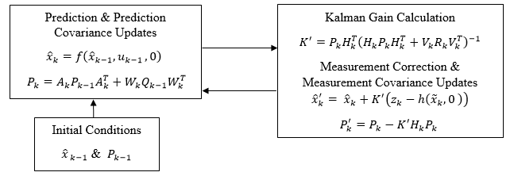

Figure 29. Extended Kalman Filter Iterative Procedure

From the figure below, it is noted the state variables and state measurement variables are non-linear functions in the following form:

Where

State Variable

= State Measurement Variable

Process Noise

Measurement Noise

Non-Linear Function of State Variables

Non-Linear Function of Measurement

Forcing Functions

For non-linear systems, process and measurement noises can be difficult to obtain, so that it is needed to linearize about an approximated point. To find this point, zero noise is assumed from a previous time step:

Once these assumptions have been established, a new set of equations can linearize, and respectively about a previous state [75, 24]:

Where

State Variable Linearized

Linearization Point from Zero Noise Assumption

State Measurement Variable Linearized

Linearization Point Measurement from Zero Noise Assumption

Jacobian of Function with respect to state variable

Jacobian of Function with respect to measurement state variable

Jacobian of Function with respect to state variable

Jacobian of Function with respect to measurement state variable

This process follows the same routine as a linearization of a multivariable function with respect to arbitrary variables x and y, about two arbitrary points “a” and “b” [75]:



In the EKF equations, Jacobians are used instead of derivatives due to the equations being in vector form. With these relationships established, the implementation of the EKF is similar to a normal Kalman Filter. A covariance matrix needs to be calculated to establish the correlation in between state variables. Then, Kalman Gain is created based from the previous information and a final measurement update is performed on both the estimated states and its respective covariance matrix.

The main problem with the EKF is that when linearizing states, their probability density functions cannot be assumed to be normal anymore. Mathematical derivations and in-depth explanation of the EKF can be found in [24].

* 1. Unscented Kalman Filter

The Unscented Kalman Filter (UKF) is known as an optimized version of the EKF. For the Kalman Filter, distribution in the state variables is approximated to be a Gaussian distribution. EKF linearization needs to change both the state variables and their distributions accordingly giving a distribution that is no longer Gaussian. This creates uncertainty problems that lead to divergence of the Filter. UKF takes this problem by only selecting a minimal set of sample points to create a representative Gaussian distribution. This method is known as an unscented transformation. Sample points (called sigma points) are selected randomly and then modified with the following equation:

Where

L = Number of state vectors

= Spread of the Sigma Points

Scaling Parameter

Equation 13 is used with the original dataset mean, and covariance to provide the Sigma Points definition.

From these sigma points, it is possible to make a normal distribution that accommodates to the new linearized functions that represent a non-linear system. Then, the steps are relatively the same as the EKF. Mathematical derivations and in-depth explanation of the UKF can be found in [25].

1. VEHICLE CONTROL
   1. Vehicle Control

Previously, filtering techniques used in autonomous vehicles mentioned a variable which reflects a state variable for the dynamics of the system. That is, all possible parameters that the vehicle needs to control. These are parameters such as steering wheel angle, acceleration, and speed. These parameters are subdivided in different sub-categories, lateral dynamics, longitudinal dynamics, driveline dynamics, and steering kinematics [26]. For each of these dynamic systems, a controller contains different mathematical estimations and measurements which are manipulated in feedback loops. These feedback loops help the system to converge to a certain value such as target velocity, or desired steering angle. Once convergence is met, the controller focuses on maintaining stability throughout operations. Figure 30 shows an example of a typical vehicle control system focusing on Longitudinal Dynamics. Many autonomous vehicle features operate under longitudinal dynamics, in which an example of a standard cruise control will suffice to illustrate the idea of vehicle control. The behavior of this longitudinal control system is summarized as follows:

* A target speed is set up in the actuator controller
* Actuator controller gives a throttle or braking command to the actuators in the engine or brakes
* Actuation of engine/brakes changes the vehicle’s longitudinal dynamics
* Longitudinal dynamics creates an actual speed that gets measured with a speedometer. Note that longitudinal dynamics are affected by input roads
* Speedometer encounters sensor noise which is filtered, and then producing final measurements
* Measurements are sent to actuator controller to adjust for further throttle or braking commands
* The process keeps repeating until a convergence of the target speed has been achieved

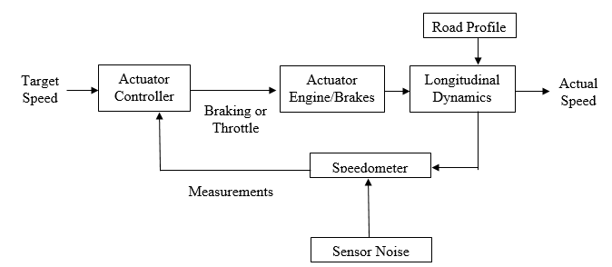

Figure 30. Block Diagram for Longitudinal Control System in a Standard Cruise Control

Each controller takes into consideration different sensors and parameter depending on the application. Summary of the different types of vehicle dynamic’s characteristics available along with their corresponding target control variables is shown in Table 4.

Table 4 Vehicle Dynamics Model and Controller for Commercial Use

|  |  |  |  |
| --- | --- | --- | --- |
| Vehicle Dynamics | Physical/Control Variables | Controller Type | Commercial Products |
| Lateral | Steering Wheel Angle, Velocity, Acceleration, Yaw Angle, Yaw Rate, Slip Angle, Wheel Steering Angle | Steering Control | Lane Keeping Assist |
| Yaw Stability Control | Lane Departure Warning |
| Electronic Stability Control | Blind Spot Warning |
| Longitudinal | Velocity, Acceleration, Motor Toque, Wheel Slip, Slip Ratio, Angular Wheel Velocity, Effective Tire Radius. | Roll Stability Control | Forward Collision Warning |
| Driveline Control | Collision Mitigation Braking |
| ABS Controller |
| Both Lateral & Longitudinal | A combination of previously mentioned variables. | A combination of previously mentioned controllers. | Adaptive Cruise Control |

Mathematical derivations of the physical system vary on the type of controller desired. Similarly, controller design is based on the target parameters to be controlled. These parameters are affected by input modes. A vehicle has three main inputs: braking, throttle (acceleration), and steering. Longitudinal controllers actuate braking and throttling. Lateral controllers can actuate all three inputs by modifying steering or modifying the brakes or throttle; thus the lateral action can govern the longitudinal actions. Further information on how vehicle dynamics are formulated along with their different controllers is found in [26].

* 1. ABS Control

An important aspect of vehicle control is the antilock braking system (ABS). The ABS system was developed to reduce aircraft landing gear wear and failure, but was subsequently applied to passenger vehicles. Since then, the ABS system has greatly evolved and sophisticated new algorithms are used. The ABS works to keep the relative difference between wheel and vehicle speed relatively constant across all four wheel during braking. ABS controls the pressure applied to each brake pad, monitoring slip, and moderates the pressure to minimize the risk of lockup. Rotating, slipping wheels produce more drag force than fully locked wheels with an optimum of 10-30% relative slip, as shown in Figure 31. This is done to maximize the amount of the braking force transmitted at each wheel by utilizing the maximum amount of available friction. This also has significant stability benefits as the vehicle is less liable to yaw during a high braking scenario. ABS is superior to non-ABS systems as they are prone to wheel lock where the friction coefficient drops significantly. It does this by monitoring the wheel speed and keeping the wheel slip percentage typically 10%-30% as given by Equation 1. The slip percentage is kept in this range because it is where the highest friction coefficient is the highest as seen in Figure 31.

The system oscillates at approximately 3 to 5 times per second to optimize braking friction [14]. It also allows the vehicle to retain some additional maneuverability in braking system that is lost when wheel lock occurs.

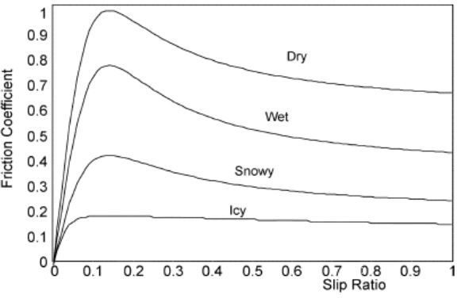

Figure 31. Slip Ratio vs Friction Coefficient [15]

Other vehicle stability systems also utilize the ABS system. The electronic stability control (ESC) system uses ABS to strategically apply braking to certain wheel if excessive yaw motion is detect to prevent the vehicle from completely losing control. The anti-slip system also utilizes ABS to reduce wheel speed on slippery surface as the same instability problems exists with slipping tires as wheel they are locked and skidding [14].

There have been many studies conducted to test the ABS. There is a wide variety of variables that impact how the ABS operate. Tire type, surface material, and surface moisture all have a major effect on ABS.

Studies have been conducted with using different car tires. In a study done three different tires were tested, a summer, all-season, and winter tires. It was found that under similar conditions the summer tire exhibited the highest acceleration values followed by the all-season tire and finally the winter tire. Testing was also conducted on dry as well as wet asphalt and the maximum deceleration was estimated to drop from 3%-8% for an ABS braked tire which can be seen in Table 5 [16].

Table 5 Average deceleration value for all tested configurations [16]

|  |  |  |  |
| --- | --- | --- | --- |
| Tire | Wet/Dry | ABS/ Locked Wheel | Average Deceleration (g) |
| Pilot PS2 | Dry | ABS | 0.98 |
| Pilot PS2 | Dry | Locked Wheel | 0.70 |
| Pilot PS2 | Wet | ABS | 0.95 |
| Pilot PS2 | Wet | Locked Wheel | 0.68 |
| MXM4 | Dry | ABS | 0.88 |
| MXM4 | Dry | Locked Wheel | 0.73 |
| MXM4 | Wet | ABS | 0.85 |
| MXM4 | Wet | Locked Wheel | 0.61 |
| Blizzak | Dry | ABS | 0.79 |
| Blizzak | Dry | Locked Wheel | 0.83 |
| Blizzak | Wet | ABS | 0.72 |
| Blizzak | Wet | Locked Wheel | 0.54 |

Studies have been conducted to test ABS on wet, icy and snowy surfaces. As it would be expected the friction coefficient drastically changes for moisture conditions. The surfaces with highest friction coefficient are surfaces that are completely dry. This is because moisture fills in the road micro-surface with water which reduces a tires contact area with the road and reduces traction [35]. When the water film height exceed average aggregate protrusion, hydroplaning can occur as the tire never directly touches the road surface but only the water coating. This increases the difficulty for keeping a vehicle under complete control in emergency braking situations. It has been shown that in certain circumstances the coefficient of friction on icy or snowy roads can drop to around 0.10, which is considerably less than the friction of a dry road which reaches frictions values of 1.2.

The available tire friction is largely effected by the road surface. The typical road surfaces of concrete and asphalt are quite similar reporting friction coefficients ranging 0.80 to 1.20. Other typical road types such as gravel and rock report as having average friction coefficients of 0.55 to 0.85 [17]. Table 6 shows friction coefficients for various surfaces. It can be seen that the difference in friction values between these surfaces can be as large as 0.65. Also when evaluating ABS performance on loose surfaces like gravel the ABS system is less effective than a wheel-locked vehicle. This is because loose surfaces allows road particles to pile up in front of the tires resulting in the vehicle stopping quicker.

Table 6 Coefficients of Friction for Different Roads [17]



When ABS is controls the braking to each individual tire is assumes that all the tires have access to similar peak friction coefficients If the vehicle is on a multi-surface road this does not hold true. Split-mu road surface conditions could potentially lead to yaw instability. Scenarios when a vehicle is on two different road surfaces simultaneously would most often occur at the side of a road. While there are many studies done on different road surfaces there are very few live testing studies done on split-mu road surfaces. There are some proposed controllers to help stabilize the vehicle in split-mu surface braking scenarios. Simulation were conducted on a split-mu road, asphalt and ice, to test a stability control system. However no live testing was conducted [18].

The vehicle ABS system is a very complex system that continues to evolve. The system goes well beyond just brake control as it is used to improve the overall stability of the vehicle in highly dynamic situations. It is a system that has undergone intense testing in a wide variety of conditions.

* 1. Path Prediction

Control systems that work to help the vehicle maintain a stable vehicle motion can employ prediction algorithms to determine a path to follow. There are two major areas in the field of vehicle path prediction. The first area uses current vehicle information and current trajectory to predict where the vehicle will go. The second research area is using sensor data about the surrounding environment and predicting a potential short term path. Vehicles can use their own processing and sensory capabilities to calculate their projected path or use sensors to estimate the future path of surrounding vehicles.

Vehicle motion is typically predicted using kinematic models. Kinematic models use the current vehicle control inputs (steering, braking, and throttle) and guidance or trajectory models which convert inputs trajectory; for example, the bicycle model. The bicycle model is shown in Figure 32 and is a simplified vehicle model which uses two wheels, one for the front axle and one for the rear axle. The weight distribution on front and rear axles is used to determine the vehicle center of gravity (c.g). This method is particularly useful when conducting short term trajectories as error produced by numerical extrapolation and integration is summative. Due to the fact that a purely kinematic approach has limited trajectory estimation power especially in highly dynamic situations, it is typically accompanied by additional prediction methods.

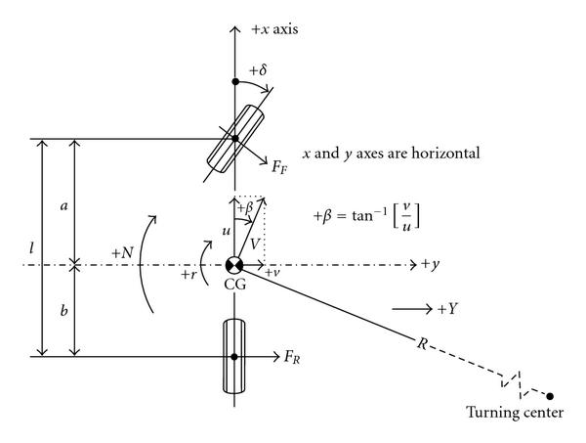

Figure 32. Diagram of Vehicle Bicycle Model [38].

a = c.g. distance from the front axis

b = c.g. distance from the rear axis

l = total length between the two axes

δ = average vehicle steering angle

β = angle on vehicle velocity as measured from the x axis (heading angle)

u = vehicle velocity in the x direction

v = vehicle velocity in the y direction

FF = lateral frictional force developed by the front axis

FR = lateral frictional force developed by the rear axis

R = the turning radius of the vehicle

r = yaw rate

The surrounding environment is also used to predict the future path of vehicle. Lane keeping assist sensors are able to view and determine the optimal relative road lane position. However, this method may be limited if the vehicle conducts more advance maneuvers, such as changing lanes or merging. Another downfall of this system is that it is critically dependent on a clear view of the road and lane markings which can be disrupted.

In many instances the optical guidance method is combined with other techniques to capable of analyzing more dynamic vehicle movements. For example, one method utilizes the current vehicle heading and also synthesizes an estimated driving maneuver (i.e. lane changing). These two data sets are used to develop a better prediction of the vehicle trajectory which is farther into the future than just based on a physics-based trajectory model alone. [1].

Obstacle detection and feature recognition for predicting and evaluating vehicle path. Parking assist makes strong use of these features. This path prediction uses information from variety of sensors like lidar, radar, and cameras. In this specific instance the vehicle will already know the generic path that must be executed to reach the desired end point. The position of all the surrounding objects is used to constantly refine the predicted path so that collisions can be avoided.

Collision detection algorithms evaluate the movements of features (e.g. other vehicles) around the vehicle and estimates if one or more of their paths will interfere with the current vehicle path. Radar and lidar are the primary sensors for detecting and trajectory adjacent vehicles. A common method of predicting a future path for the adjacent vehicle is by compiling the position history of vehicle constructing an estimated future trajectory. The predicted path is compared with the trajectory of the host vehicle to determine if there is any collision risk, and whether or not action is needed.

* 1. Vehicle Communications

A new step taken in autonomous vehicles is to incorporate vehicle communications which permit the vehicle to obtain more information that otherwise it could not obtain. The information can come from multiple sources such as other vehicles and different infrastructure. These communications are divided into their respective receiver-transmitter categories. For example V2V for vehicle to vehicle communications, and V2I for vehicle to infrastructure communications. These types of systems are also divided up into two main types of action which are active and passive actions. If the vehicle uses communications for passive actions, the signals are sent and displayed to drivers in the vehicle so that drivers can take according action. For active systems, the vehicle uses signal information to compute preventive measures and take control of the vehicle to avoid collisions. Usually, V2V are active communication systems and V2I are passive communication systems. All vehicle communications have designated operating signal frequencies. For Public Safety and private operations in roadside, and vehicles, Dedicated Short Range Communications (DSRC) have 75MHz of spectrum in the used in the 5.9 GHz band [27], [28].

V2V communications focuses on sending vehicle parameters such as current speed and accelerations to neighboring vehicles. This will permit vehicles to detect abrupt changes before an on board sensor from an observer vehicle could. During events such as abrupt braking, the braking vehicle sends a signal at the moment the brake has been abruptly activated, allowing neighboring vehicles to take preventive action. Otherwise, the neighboring vehicles would have to wait until the braking vehicle reflects a sudden change in their behavior before even analyzing the probability of danger. This usually takes too much time due to lag on braking systems of the vehicle, sensor delay and processing on the nearby vehicles. V2V solves this issue by sending this type of abrupt conditions to other vehicles before it gets reflected on the physical vehicle. The main drawback that V2V communication encounters is that not all vehicles would contain the same type of communication. This poses many communication limitations when most vehicles do not contain V2V communications onboard.

V2I communications sends vehicle information over relatively long distances to other vehicles regarding dangerous or heavy vehicle traffic flows. This allows drivers and vehicles to take preventive actions before reaching this traffic flows. In the case of car crash accidents, congestions, or constructions, infrastructures detect low traffic flows and notify it on coming vehicles so that vehicles can deviate and take different routes. Since the systems tend to be passive, these do not pose a priority in the hierarchy of control actions, so that confusion can exists in between what the vehicle tries to do and the action that is being sent by infrastructures.

In both cases, research is being done in both V2I and V2V communications with the objective of full implementation of vehicle communications in the near future. New developments include V2B for vehicle to barrier communications. This type of communications offer an alternative of V2I that is focused on rapid-emergency responses for crash prevention at high speeds.

1. TRAFFIC MANAGEMENT
   1. Intersection Control

As the size of the current vehicle fleet increases, so does the need for more sophisticated traffic management systems. There are many systems being researched and patented to improve the efficiency of congested traffic flow, such as control logic. One method of advanced intersection control is the use of fuzzy logic to control traffic lights. Systems using decision making programs use sensors to collect traffic data including traffic densities, to prioritize light timing to maximize flow through. These logical intersection control systems have clear advantages over basic fixed timing loops as they dynamically change based on the current traffic. There are various implementations and algorithms that all work to maximize the efficiency of a logically controlled system. Some systems not only use the data that they gather, but also receive data from other intelligent intersection and data collecting sensors to assist in making decisions.

Other systems use V2I communication to improve traffic flow. One application requires the vehicle to transmit its position and current heading to the intersection node, and based on the collection of information from all of the vehicles, light timing for stop condition (e.g. red light warning) is transmitted to the vehicle before entering the intersection. [2]. Challenges with this system suggest that its usefulness may be best applied at lower volume situations like four way stops.

* 1. Pedestrian Detection

Another area of research being conducted is pedestrian detection and tracking. Vehicles may use optical techniques to identify pedestrians and reduce the likelihood of pedestrian impact particularly due to crossings. This evolving field is critical, as existing ADAS features struggle to reliably identify pedestrians. Hardware placed at crosswalks is the most common research being done in the field of pedestrian detection. The hardware used greatly differs from system to system, but the most typical applications use lidar, radar, infrared, and cameras. In most cases, the systems use a combination of two or more sensors for signal fidelity. For examples cameras may detect pedestrians through pixel recognition, when lighting is sufficient clearly distinguish pedestrians. Another common method is to use infrared cameras at intersections to detect pedestrians. A major benefit of this type of system is that it is less affected by weather conditions and time of day.

A few studies have taken to model pedestrian paths in intersections. Research done at Ohio State University (OSU) modeled pedestrian motion across at the OSU Transportation Hub [3]. This was done to model vehicles like small scooters and carts in the same space as pedestrians.

There are many challenges to effectively capture pedestrian movements and warn approaching vehicles. Some things that hide pedestrians from view, such as umbrellas and other coverings, may “fool” optical sensors. Pedestrians may also attempt to cross outside the view of the sensors or travel in groups making individual identification difficult [4].

* 1. Vehicle Platooning

Another research area being explored is in the area of platooning vehicles, primarily to haul large, multi-vehicle shipments. The basis of platoon traveling is that multiple vehicles travel in close proximity with each other, usually in groups of about eight. The lead vehicle is in charge of the platoon as it sets the speed. All the vehicles are in constant communication with each other which allows them to sync to a constant speed. This allows the vehicles to be in close proximity to take advantage of reduced aerodynamic drag. Additionally, one of the causes of congestion and traffic jams, the cascading effect due to repetitive braking and accelerating is greatly reduced by controlling longitudinal motion of multiple vehicles simultaneously. [33, 39, 44]. Platooning is currently utilized by the heavy trucking industry to improve fuel efficiency. Due to their immense mass heavy truck dynamics are more difficult to minutely adjust. Research conducted into truck platooning has a main objective of safely platooning to increase fuel efficiency. One issue with truck is that their speed is more effected by road slopes. Topographical maps can help truck platoons prepare for changes in road slopes and stay in close proximity [43]. Cars traveling in such close proximity pose a lot of potential risk should communication between the vehicles be interrupted. Additionally issues could potentially arise with vehicles trying to join or leave the platoon as their destination is reached.

* 1. Vehicle Communications

A new step taken in autonomous vehicles is to incorporate vehicle communications which permit the vehicle to obtain more information that otherwise it could not obtain. The information can come from multiple sources such as other vehicles and different infrastructure. These communications are divided into their respective receiver-transmitter categories. For example V2V for vehicle to vehicle communications, and V2I for vehicle to infrastructure communications. These types of systems are also divided up into two main types of action which are active and passive actions. If the vehicle uses communications for passive actions, the signals are sent and displayed to drivers in the vehicle so that drivers can take according action. For active systems, the vehicle uses signal information to compute preventive measures and take control of the vehicle to avoid collisions. Usually, V2V are active communication systems and V2I are passive communication systems. All vehicle communications have designated operating signal frequencies. For Public Safety and private operations in roadside, and vehicles, Dedicated Short Range Communications (DSRC) have 75MHz of spectrum in the used in the 5.9 GHz band [27], [28].

V2V communications focuses on sending vehicle parameters such as current speed and accelerations to neighboring vehicles. This will permit vehicles to detect abrupt changes before an on board sensor from an observer vehicle could. During events such as abrupt braking, the braking vehicle sends a signal at the moment the brake has been abruptly activated, allowing neighboring vehicles to take preventive action. Otherwise, the neighboring vehicles would have to wait until the braking vehicle reflects a sudden change in their behavior before even analyzing the probability of danger. This usually takes too much time due to lag on braking systems of the vehicle, sensor delay and processing on the nearby vehicles. V2V solves this issue by sending this type of abrupt conditions to other vehicles before it gets reflected on the physical vehicle. The main drawback that V2V communication encounters is that not all vehicles would contain the same type of communication. This poses many communication limitations when most vehicles do not contain V2V communications onboard.

V2I communications sends vehicle information over relatively long distances to other vehicles regarding dangerous or heavy vehicle traffic flows. This allows drivers and vehicles to take preventive actions before reaching this traffic flows. In the case of car crash accidents, congestions, or constructions, infrastructures detect low traffic flows and notify it on coming vehicles so that vehicles can deviate and take different routes. Since the systems tend to be passive, these do not pose a priority in the hierarchy of control actions, so that confusion can exists in between what the vehicle tries to do and the action that is being sent by infrastructures.

In both cases, research is being done in both V2I and V2V communications with the objective of full implementation of vehicle communications in the near future. New developments include V2B for vehicle to barrier communications. This type of communications offer an alternative of V2I that is focused on rapid-emergency responses for crash prevention at high speeds.

* 1. Emergency Response

Research is being conducted to improve emergency vehicle and passenger vehicle communication for faster response times, improved survivability, and other traffic management. For emergency vehicles, it is important that they notify the nearby infrastructure and other vehicles of their presence. Passenger vehicles can also aide emergency response by notifying emergency services of an incident as quickly as possible.

* + 1. Emergency Vehicle Preemption

A factor that has an enormous effect on response time is emergency vehicle preemption. Preemption happens as the emergency vehicle approaches an intersection and communicates with the traffic light to switch the light timing to give the emergency vehicle the right-of-way. This is done by using radio sensors, optical sensor, a sound senor, GPS communication, or sensor networks. Optical and sound sensors are the simplest and widely implemented. The lights and sirens that are used on emergency vehicles are used to trigger these sensors to start the preemption process. However, these have a limited range. This also becomes an issue when the intersection is congested. Optical systems can also have issues in inclement weather and audio receivers can suffer due to noise pollution.

Radio and GPS can be used to not only communicate over a wider range but also broadcast additional information Using radio signaling is an effective way to broadcast a signal from an emergency vehicle to an intersection control system. The radio signal is less affected by different weather conditions as optical or audio sensors may be. Using radio signals, emergency vehicles can transmit their current heading information so that the control system can change the traffic signal at the correct time rather than just changing right when the vehicle is in range. This helps to reduce any waiting need to be done by the emergency vehicle [41, 42].

Another level to using GPS for emergency preemption is using a GPS navigation path. In one embodiment the quickest route to an emergency in calculated based on a combination of current traffic and the shortest distance. Once the route is calculated the affected intersections along the route are notified using a cellular signal. The intersections are equipped with pressure sensors to determine the amount of vehicles currently at the intersection. This is used to determine the time need to clear the intersection in the direction of travel of the emergency vehicle. The emergency vehicle transmits its current position and its time of arrival to the intersection, is controlled to vacate in-direction lane congestion and allow the emergency vehicles to pass through [5]. This method is very intricate but it eliminates a major problem with emergency vehicles navigating intersections, an accumulation of vehicles waiting at the intersection in front of the emergency vehicle. This method is not currently implemented by any organizations.

* + 1. Emergency Vehicle V2V Communication

Another area of research related to emergency vehicles is the use of V2V communication to alert drivers of the presence of emergency vehicles. This is an added layer to using lights and sirens to alert the drivers as drivers may not see or hear the vehicle immediately. Emergency vehicles are able to use radio signals to transmit their information to the vehicles around them. Such systems use the audio in the vehicle to alert the driver to the presence and the direction of the emergency vehicle. This ensures that motorist are alerted in a timely manner but also informs them of the direction of travel so they can determine if they are affected and whether or not they need to take action [45].

* + 1. Accident Notification

Accident notification also play a large role in the response time of emergency vehicles. Methods are being developed, using vehicle sensors, to automatically notify emergency services and transportation services. An automatic response by the vehicle is an efficient method because it can do this immediately after the accident. It takes a few moments for the passengers and the bystanders to processes the situation and then take appropriate action. In addition the vehicle can transmit the exact location of the accident. The vehicle can also communicate with smart infrastructure to notify and possibly reroute traffic around the accident if necessary [40].

There are many different research areas in the emergency response. However they are all based on reducing response time. This is done by both emergency vehicles and passenger vehicles communicating with each other and with smart infrastructure. All of these entities work together to relay necessary information so that the all incidents can be resolved as efficiently as and normal traffic flow can be resumed.

1. CYBERSECURITY

In the development of a smarter transportation paradigm it is essential that new systems not only improve efficiency but also ensure the safety of all of the people on the road. In the advent of advanced vehicle communication a major safety threat is cyber-attacks. Automations helps to increase the overall efficiency but it also increases the number of systems that can be hacked. Computerized systems within the vehicle, vehicle sensors, and other vehicle communication is all vulnerable to cyberattacks. If the system can be infiltrated by hackers it can essentially be rendered useless and create more problems.

Modern vehicles are highly computerized and are controlled by hundreds of electronic systems [6]. Systems like braking, steering and other control systems are control by the vehicles centralized computer. Cellular and internet connections built into the vehicle processors can also increase system override and vulnerability. This makes these systems accessible to anyone that can establish contact and infiltrate the vehicle system. There have been several instances of researches hacking into a vehicles onboard computer and controlling the vehicle from miles away to show the vulnerabilities of existing systems. Currently there has been only one reported instance in which someone has maliciously hacked into other vehicles. However, the individual used a system installed by a car dealership to enforce loan repayment which wasn’t active while the vehicles were running [7].

In addition, external vehicle sensors can be tampered. The signals give off by radar and lidar can be disabled in a number of ways. The radio waves give off from the radar sensors can be interfered with by sending a jamming or canceling wave to the sensor. The signal can also be spoofed by a separate radio signal to broadcast false readings [8]. Lidar can also be corrupted by shooting lasers at the lidar senor which will incite false readings.

Vehicle communication systems have many potential security risks as well. Many V2V and V2I communications systems rely of direct short-range communication (DSRC) to transmit data. Just as with vehicle radar sensors, DSRC is prone to similar disruption attacks. One major area of concern aside from signal disruption is the broadcasting of false information across a communication network. If incorrect information is intentionally input into the vehicle, results could be disastrous. Reliable methods for validating incoming data packets are currently being researched.

One validation method that is of significant interest is the use of blockchain to create a reliable information transfer system and is being investigated by a couple of transportation research groups [9][34]. Blockchain works by creating a ledger of the history of the data that is time stamped. The data is decentralized and carried and verified by a series of independent servers. The process makes it difficult to add false data into the system since it is verified by nodes other than the one that is being transmitted to and it is compared against the ledger created by the data that had be previously transferred [9].

Ensuring the security and accuracy of transportation is vital to the success of a fully connected transportation network. As it currently stands a definite solution does not exist to do so. However, as vehicles become more autonomous and people become more dependent on new technology, this area becomes more important. To be able to realize a transportation paradigm in which everything is completely connected and almost fully autonomous, the security of the system needs to be nearly impenetrable. Since everything would be connected one infiltration would have repercussive results and can bring everything to a halt.

1. SUMMARY AND FURTURE WORK
   1. Report Summary

Current vehicle and transportation technology was explored to gain an understanding of the current status of the current technology and how the various system and hardware operate to help identify the strengths and weakness of the systems~~.~~

The current vehicle market was researched and the recent vehicle features were discovered. On current vehicle models there are a few systems available that assist the driver to remain in their lane and avoid collision. Some of these systems are monitory and only warn the driver if it is deemed necessary while others can take active control over the vehicle in given instances. These systems are extract data from hundreds of sensor for all around the vehicle as summary of which can be found in Appendix A. These sensors monitor all of the systems inside the vehicle and additional sensors are located on the outside to detect important environment details. The sensors inside of the vehicle have much higher degree of accuracy than the sensors used for environment detection. The accuracy of sensors significantly increase the cost of the vehicle”. Since the number of sensors usually remains similar in newer vehicle models. Some sensors like lidar are too expensive and undeveloped for consumer vehicles.

The internal vehicle sensors are used in vehicle control systems. Nearly every part of modern vehicles is controlled by the ECU. This is done because the use of the computer can greatly increase the efficiency and accuracy of systems and optimizing the systems based on current demands. One system that is highly computerized is the ABS. ABS relies entire on the sensor data to control braking efficiently and many studies have been conducted to evaluate its limits based on different road surfaces, moisture content, and tire types. One area were very little testing has be conducted is in braking on split-mu road conditions.

Sensors on the outside of the vehicle are a resent development. These sensors are responsible for analyzing and describing the vehicle’s environment so that driver assistance programs are able to make corrected decisions. The most relevant sensors are video cameras, radar, and ultrasonic sensors. Each uses different processes the environment differently and each one has its own strengths and thus are used for specific purposes. However none of these sensors is completely accurate and currently used only for certain tasks and not completely operated the vehicle the entire time.

In order for sensor data to be useful must first be processed so, filtering techniques were researched. Once the data is processed it is used in a variety of control systems. These systems are not only used purely for control loops but also used in prediction models, like path prediction models. These models range in sophistication and used to help the vehicle remain on the road and avoid collisions.

Not only has vehicle technology evolved but transportation systems have as well. All of the improvement are geared to increase traffic efficiency and it is done in a variety of ways. One way, is improving intersection control which increases traffic flow and reduces emergency response time in vehicles.

The last area of interest that was understand some of the cybersecurity involvement in transportation. As it can be seen in the report summary almost every vehicle component is computerized and that will only grow as vehicles increase in automation. Additionally many transportation systems like intersections and vehicle communication are computerized. When something is computerized it is also hackable. As we move to a more connected transportation system that issue becomes more important. There are different methods that are being researched to reduce the hack-ability of the computer systems but it is an area that needs a significant amount of attention.

The main take away from all of the researched vehicle and transportation technology is that no system is perfect and there are serious lapses in being able to always be safely in control of the vehicle. Some of these issues will be corrected by further research and development of the current systems and sensors. However it still will not be able to accurately detect and control everything. This is basis for the vehicle assistance control paradigm shift to integrating infrastructure communication systems to become the primary information source.

* 1. Future Work

After conducting research into the current vehicle and transportation market we are looking to take the next step in toward and V2I communication system to assist the control of the vehicle. As mention previously ABS testing on split-mu surfaces is underdeveloped research topic. The next immediate step will be to conduct split-mu ABS testing to evaluate the system behavior under such conditions. This is especially prevalent to our proposed system as road departures can involve multiple road surfaces. The next phase of the project will also consist of beginning to delve into constructing mathematical models for vehicle motion and for describing road profiles and conducting computer simulations to evaluate the performance of the theorized models.

1. REFERENCES
2. Xie, G., Gao, H., Qian, L., Huang, B., Li, K., and Wang, J., *Vehicle Trajectory Prediction by Integrating Physics- and Maneuver-Based Approaches Using Interactive Multiple Models*, Volume 65, Issue 7, IEEE Transaction on Industrial Electronics, IEEE, New York, New York, July 2018, pages 5999-6008.
3. Borland, B.K., Funke, B.G., and Chacko, M., *Traffic Management,* U.S. Patent 8,847,788 issued September 30, 2014.
4. Yang, D., Kurt, A., Redmill, K., and Özguner, Ü., *Agent-based Microscopic Pedestrian Interaction with Intelligent Vehicles in Shared Space*, Proceedings of the 2nd International Workshop on Science of Smart City Operations and Platforms Engineering, Association for Computing Machinery, Pittsburgh, Pennsylvania, April, 2017, pages 69-74.
5. Fascioli, A., Fedriga, R. I., and Ghidoni, S., *Vision-based monitoring of pedestrian crossings*, 14th International Conference on Image Analysis and Processing, IEEE, New York, New York, September 2007, pages 566-574.
6. Eltayeb, A. S., Almubarak, H. O., and Attia, T. A., *A GPS Based Traffic Light Pre-emption Control System for Emergency Vehicles*, 2013 INTERNATIONAL CONFERENCE ON COMPUTING, ELECTRICAL AND ELECTRONIC ENGINEERING, IEEE, New York, New York, August 2013, pages 724-729.
7. Eiza, M. H., and Ni, Q., *Driving with Sharks Rethinking Connected Vehicles with Vehicle Cybersecurity*, Volume 12, Issue 2, IEEE Vehicular Technology Magazine, IEEE, New York, New York, April 2017, pages 45-51.
8. WIRED, Hacker Disables More than 100 Cars Remotely, Available: <<https://www.wired.com/2010/03/hacker-bricks-cars/>> July 16, 2018.
9. Yeh, E. R., Choi, J., Prelcic, N. G., Bhat, C., and Heath Jr, R. W. *Cybersecurity Challenges and Pathways in the Context of Connected Vehicle Systems*, Technical Report 134, Data-Supported Transportation Operations & Planning Center , Austin, Texas, February 2018.
10. Rajbhandari, R., *Exploring Blockchain – Technology behind Bitcoin and Implications for Transforming Transportation*, PRC 17-13 F, Texas A&M Transportation Institute, College Station, Texas, January 2018.
11. Mustafah, Y. M., Noor, R., and Hasbi, H., *Stereo vision images processing for real-time object distance and size measurements*, 2012 International Conference on Computer and Communication Engineering, IEEE, New York, New York, July 2012, pages 659-663.
12. Sivaraman, S., and Trivedi, M. M., *Looking at Vehicles on the Road: A Survey of Vision-Based Vehicle Detection, Tracking, and Behavior Analysis*, Volume 14, Issue 4, IEEE Transactions on Intelligent Transportation Systems, IEEE, New York, New York, December 2013, pages 1773-1795.
13. Cheng, J., Xiang, Z., Cao, T., and Liu, J., *Robust Vehicle Detection using 3D Lidar under Complex Urban Environment*, 2014 IEEE International Conference on Robotics and Automation, IEEE, New York, New York, June 2014, pages 691-696.
14. Dooley, D., McGinley, B., Hughes, C., Kilmartin, L., Jones, E., and Glavin, M., *A Blind-Zone Detection Method Using a Rea-Mounted Fisheye Camera With Combination of Vehicle Detection Methods*, Volume 17 Issue 1, IEEE Transactions on Intelligent Transportation Systems, IEEE, New York, New York, January 2016, pages 264-278.
15. *Anti-Lock Braking System (ABS) and Anti-Slip Regulation (ASR)*, 2nd Edition, WABCO, 2011.
16. Junhui, L., and Jianqiang, *Road Surface Condition Detection based on Road Surface Temperature and Solar Radiation*, Volume 6, 2010 International Conference on Computer, Mechatronics, Control and Electronic Engineering, , IEEE, New York, New York, August 2010, pages 4-7.
17. Leiss, P. J., Becker, S., and Derian, G., *Tire Friction Comparison of Three Tire Types*, SAE Technical Paper 2013-01-0783, SAE, April 2013.
18. Fricke, L. B., and Baker, J. S., *Drag Factor and Coefficient of Friction in Traffic Accident Reconstruction: Topic 862 of the Traffic Accident Investigation Manual*, Northwestern University Traffic Institute, 1990.
19. Zhou, S., and Zhang, S., *Study on Stability Control during Split-mu ABS Braking*, 2011 Chinese Control and Decision Conference, IEEE, New York, New York, May 2011, pages 1235-1239.
20. IEEE Spectrum, Centimeter-Level GPS Positioning for Cars, Available: <https://spectrum.ieee.org/cars-that-think/transportation/sensors/centimeterlevel-gps-positioning-for-cars> July 17, 2018.
21. EOS Positioning Systems, How to Set Up Your Own RTK Base Station with GNSS Receivers, Available: < https://eos-gnss.com/setting-up-your-own-rtk-base-station-arrow/> July 18, 2018.
22. Rose, C., Britt, J., Allen, J., and Bevly, D., *An Integrated Vehicle Navigation System Utilizing Lane-Detection and Lateral Position Estimation Systems in Difficult Environments for GPS*, Volume 15, Issue 6, IEEE Transactions on Intelligent Transportation Systems, IEE, New York, New York, December 2014, pages 2615-2629.
23. Marek, J., Trah, H.-P., Suzuki, Y., Yokomori, I., *Sensors for Automotive Technology*, Volume 4, John Wiley & Sons, Inc., 2003.
24. Bosch Group, *Automotive Handbook*, 9th edition, John Wiley & Sons, Inc., October 2014.
25. Welch, G., Bishop, G., *An Introduction to the Kalman Filter*, TR 95-041, University of North Carolina at Chapel Hill, July 2006.
26. Wan, E. A., Merwe, R. V. D., *The Unscented Kalman Filter for Nonlinear Estimation*, Proceedings of the IEEE 2000 Adaptive Systems for Signal Processing, Communications, and Control Symposium, IEEE, New York, New York, October 2000, pages 153-158.
27. Rajamani, R.., *Vehicle Dynamics and Control,* Second Edition, Springer, 2012.
28. United States Department of Transportation, SAE J2735 - Dedicated Short Range Communications (DSRC) Message Set Dictionary, Available:<https://www.standards.its.dot.gov/Factsheets/Factsheet/71>July 19, 2018.
29. Federal Communications Commission, FCC Allocates Spectrum in 5.9 GHz Range for Intelligent Transportation Systems Uses, Available:<https://transition.fcc.gov/Bureaus/Engineering_Technology/News_Releases/1999/nret9006.html>July 19, 2018.
30. United States Department of Transportation, Roadway Departure Safety, Available:<https://safety.fhwa.dot.gov/roadway_dept/>July 23, 2018.
31. Andrews, S., *Vehicle-to-Vehicle (V2V) and Vehicle-to-Infrastructure (V2I) Communications and Cooperative Drivering,* Handbook of Intelligent Vehicles, Eskandarian (ed), Springer-Verlag, London, 2012. DOI 10.1007/978-0-85729-085-4_46
32. *V2V/V2I Communications for Improved Road Safety and Efficiency*, Jurgen, R.K., (ed), Society of Automotive Engineers, Warrendale, PA, 2012. ISBN 978-0-7680-7725-4
33. Devilly, O., and O’Mahony, M., *Assessing the Benefits of Installing V2I Communications on an Urban Orbital Motorway in a Medium Sized European City*, Journal of the Transportation Research Board, Washington, D.C., January 2018
34. Fernandes, P., and Urbano, N., *Platooning With IVC-Enabled Autonomous Vehicles: Strategies to Mitigate Communication Delays Improve Safety and Traffic Flow,* Volume 13, Issue 1, IEE Transactions on Intelligent Transportation Systems, New York, New York, March 2012.
35. Merrefield, C., *What Blockchains Could Mean for Government and Transportation Operations*, DOT-VNTSC-18-03, U.S. Department of Transportation, Cambridge, Massachusetts, January 2018.
36. Flintsch, G. W., McGhee, K. K., Izeppi, E. L., and Najafi, S., *The Little Book of Tire Pavement Friction*, Version 1.0, Connecticut Department of Transportation, September 2012.
37. Adarsh, S., Kaleemuddin, S. M., Bose, D., and Ramachandra, K. I., *Performance comparison of Infrared and Ultrasonic sensors for obstacles of different materials in vehicle/ robot navigation applications*, Volume 149, IOP Conference Series: Materials Science and Engineering, October 2016.
38. Lim, B. S., Keoh, S. L., and Thing, V. L. L., *Autonomous Vehicle Ultrasonic Sensor Vulnerability and Impact Assessment*, ISBN: 978-1-4673-9944-9,2018 IEEE 4th World Forum on Internet of Things, IEEE, New York, New York, February 2018, pages 231-236.
39. Hindawi, Experiential Learning in Vehicle Dynamics Education via Motion Simulation and Interactive Gaming, Available:<<https://www.hindawi.com/journals/ijcgt/2009/952524/fig9/>> July 24, 2018.
40. Tiernan, T. A., Richardson, N., Azeredo, P., Najm, W. G., and Lochrane, T. *Test and Evaluation of Vehicle Platooning Proof-Of-Concept Based on Cooperative Adaptive Cruise Control*. U.S. Department of Transportation, Cambridge, MA, April, 2017.
41. Tannenbaum, A. B., *System AND METHOD OF USE FOR MANAGING SAFETY INCIDENT AND ACCIDENT FIRST RESONSE*, Patent No. US 9,928,744 B1, March 2018.
42. Hall, T. J., Schwartz, M. A., and Hamer, S. M., *GPS-BASED TRAFFIC CONTROL PREEMPTION SYSTEM*, Patent No. US 5,539,398, Minnesota Mining and Manufacturing Company, St. Paul, MN, July 1996.
43. Jones, G. V., Hatch, R. R., Hume, J. R., and Keegan, R. G., *AUTOMATICE DETERMINATION OF TRAFFIC SIGNAL PREEMPTION USING DIFFERENTIAL GPS*, Patent No. US 5,926,113, L & H Company, Inc., Oak Brook, IL, July, 1999.
44. Turri, V., Besselink, B., and Johansson K. H., *Cooperative Look-Ahead Control for Fuel-Efficient and Safe Heavy-Duty Vehicle Platooning,* Volume No. 25, IEEE Transactions on Control Systems Technology, IEEE, New York, New York, January 2017, pages 12-28.
45. Santini, S., Salvi, A., Valente, A. S., Pescape, A., Segata, M., and Cigno, R. L., *A Consensus-Based Approach for Platooning with Intervehicular Communications and Its Validation in Realistic Scenarios*, Volume No. 66, IEEE Transactions on Vehicular Technology, IEEE, New York, New York, March 2017, pages 1985-1999.
46. Markow, P. A., *DIRECTIOONAL WARNING SYSTEM FOR DETECTING EMERGENCY VEHICLES*, Patent No. US 6,087,961, DaimlerChrysler Corporation, Auburn Hills, MI, July 2000.
47. Honda, Honda Sensing, Available: <<https://automobiles.honda.com/sensing>> September 20, 2018
48. Toyota, Toyota Safety Sense Comes Standard On Many New Toyotas, Available: <<https://www.toyota.com/safety-sense/>> September 20, 2018.
49. Nissan, Nissan Intelligent Mobility, Available: <<https://www.nissanusa.com/intelligent-mobility>> September 20, 2018.
50. Ford, Explore 2019 Fusion Smart Features, Available: <<https://www.ford.com/cars/fusion/features/smart/>> September 20, 2018.
51. Tesla, Autopilot, Available: <<https://www.tesla.com/autopilot>> September 20, 2018.
52. NHTSA, Automated Vehicles for Safety, Available: <<https://www.nhtsa.gov/technology-innovation/automated-vehicles-safety#issue-road-self-driving>> September 20, 2018.
53. Safercar, Forward Collision Warning Systems, Available: <<https://www.safercar.gov/Vehicle-Shoppers/Safety-Technology/fcw>> September 20, 2018.
54. Honda, Collision Mitigation Braking System, Available: <<http://owners.honda.com/vehicles/information/2018/Accord-Sedan/features/Collision-Mitigation-Braking-System/2>> September 20, 2018.
55. Safecar, Pedestrian Automatic Emergency Braking, Available: <<https://www.safercar.gov/Vehicle-Shoppers/Safety-Technology/paeb>> September 20, 2018.
56. Nissan Motor Corporation, Intelligent Emergency Braking (“Automatic Emergency Braking” for USA), Available: <<https://www.nissan-global.com/EN/TECHNOLOGY/OVERVIEW/emergency_brake.html>> September 20, 2018.
57. Park, M. K., Lee, S. Y., Kwon, C. K., and Kim, S. W., *Design of Pedestrian Target Selection With Funnel Map for Pedestrian AEB System*, Volume 66 No. 5, IEEE Transactions of Vehicular Technology, IEEE, New York, New York, May 2017, pages 3597-3609.
58. Kopetz, H., and Poledna, S., *Autonomous Emergency Braking: A System-of-Systems Perspective*, 2013 43rd Annual IEEE/IFIP Conference on Dependable Systems and Networks Workshop (DSN-W), IEEE, New York, New York, June 2013.
59. Han, I. C., Luan, B. C., and Hsieh, F. C., *Development of Autonomous Emergency Braking Control System Based on Road Friction,* 2014 IEEE International Conference on Automation Science and Engineering, IEEE, New York, New York, August, 2014, pages 933-937.
60. Mahajan, R. N., and Patil, A. M., *Lane Departure Warning System,* Volume 3 Issue 1, International Journal of Engineering and Technical Research, Engineering Research Publication, January, 2015, pages 120-123.
61. Ercan, Z., Gokasan,M., and Borrelli, B., *An Adaptive and Predictive Controller Design for Lateral Control of an Autonomous Vehicle,* 2017 IEEE International Conference on Vehicular Electronics and Safety, IEEE, New York, New York, June, 2017, pages 13-18.
62. Pereira, G. C., Svensson, L., Lima, P. F., and Martensson, J., *Lateral Model Predictive Control for Over-Actuated Autonomous Vehicle,* 2017 IEEE Intelligent Vehicles Symposium, IEEE, New York, New York, June 2017, pages 310-316.
63. Falcone, P., Tseng H. E., Borrelli, F., Asgari, J., and Hrovat, D., *MPC-Based Yaw and Lateral Stabilization Via Active Front Steering and Braking,* Volume 46 Supplement 1, Vehicle System Dynamics, January 2008, pages 611-628.
64. Falcone, P., Borrelli, F., Asgari, J., Tseng H. E., and Hrovat D., *Predictive Active Steering Control for Autonomous Vehicle Systems,* Volume 15 No. 3, IEEE Transactions on Control Systems Technology, IEEE, New York, New York, May 2007, pages 566-580.
65. Glaser, S., Mammar, S., and Sentouh, C., *Integrated Driver-Vehicle-Infrastructure Road Departure Warning Unit,* Volume 59 No. 6, IEEE Transactions on Vehicular Technology, IEEE, New York, New York, July, 2010, pages 2757-2771.
66. Mammar, S., Glaser, S., and Netto, M., *Time to Line Crossing for Lane Departure Avoidance: A Theoretical Study and an Experimental Setting*, Volume 7 No. 2, IEEE Transactions on Intelligent Transportation Systems, IEEE, New York, New York, June 2006, pages 226-241.
67. Enache, N. M., Mammar, S., Netto, M., and Lusetti, B., *Driver Steering Assistance for Lane Departure Avoidance Based on Hybrid Automata and Composite Lyapunov Function*, Volume 11 No. 1, IEEE Transactions on Intelligent Transportation Systems, IEEE, New York, New York, March 2010, pages 28-39.
68. Wang, Y., Feng, R., Pan, D., Liu, Z., Wu, N., and Li, W., *The Trajectory Planning of the Lane Change Assist Based on the Model Predictive Control with Multi-Objective,* SAE International, Warrendale Pennsylvania, September 2017.
69. Falcone, P., Borrelli, F., Tseng, H. E., Asgari, J., and Hrovat D., *Integrated Braking and Steering Model Predictive Control Approach in Autonomous Vehicles.*
70. Garshelis, I. J., and Crevecoeur, G., *A Simple Magnetostatic Sensing Method for Assessing the Local Hysteresis Properties in Ferromagnetic Sheet Materials,* Volume 2012, Journal of Sensors, Hindawi, March 2012.
71. MyShared, Hyundai Service Training, Available: <[http://www.myshared.ru/slide/886738/#](http://www.myshared.ru/slide/886738/)> September 20, 2018.
72. Maxim Integrated, Variable-Reluctance Sensor Interface with Differential Input and Adaptive Peak Threshold, Available: <https://www.maximintegrated.com/en/products/sensors/MAX9924.html> September 20, 2018.
73. Zhang, X., Gao, F., and Li, X., *Sensing Performance Analysis on Quartz Tuning Fork-Probe at the High Order Vibration Mode for Multi-Frequency Scanning Probe Microscopy,* Volume 18 Issue 2, Sensors, MDPI, Basel, Switzerland, January 2018.
74. Xia, D., Yu, C., and Kong, L., *The Development of Micromachined Gyroscope Structure and Circuitry Technology,* Volume 14 Issue 1, Sensors, MDPI, Basel, Switzerland, January 2014.
75. National Instruments, Sensor Terminology, Available: <<http://www.ni.com/white-paper/14860/en/>> September 21, 2018.
76. Embedded Vision Alliance, Automotive Fusion: Combining Legacy and Emerging Sensors for Safer and Increasingly Autonomous Vehicles, Available: < <https://www.embedded-vision.com/platinum-members/embedded-vision-alliance/embedded-vision-training/documents/pages/adasfusion>> September 22, 2018
77. APPENDICES
78. Current Vehicle Sensors

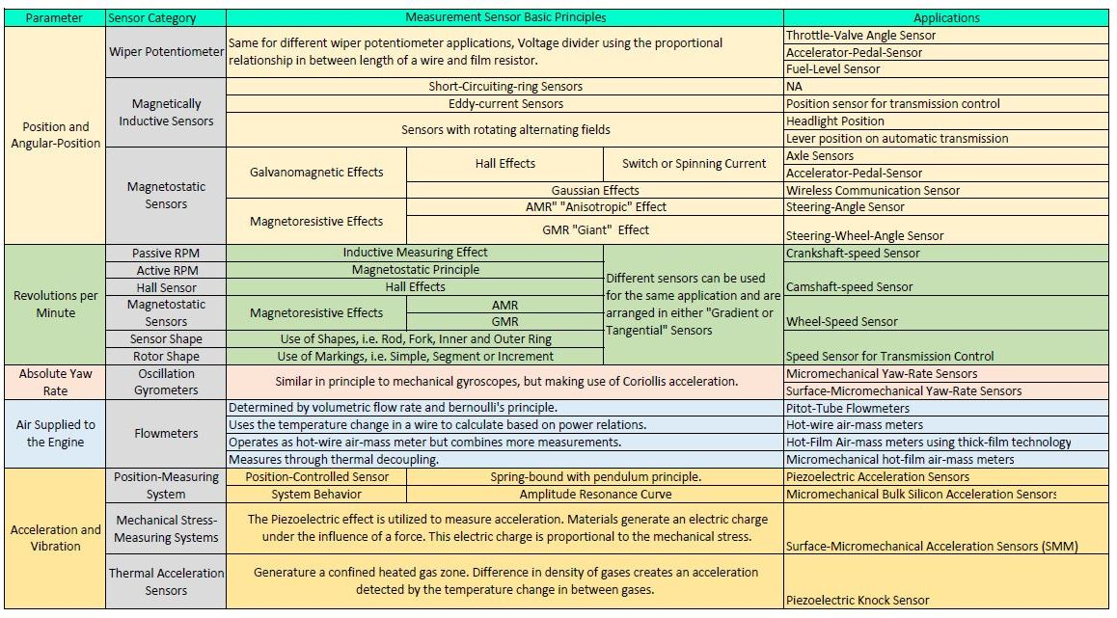

* 1. Sensors Available on Current Vehicles

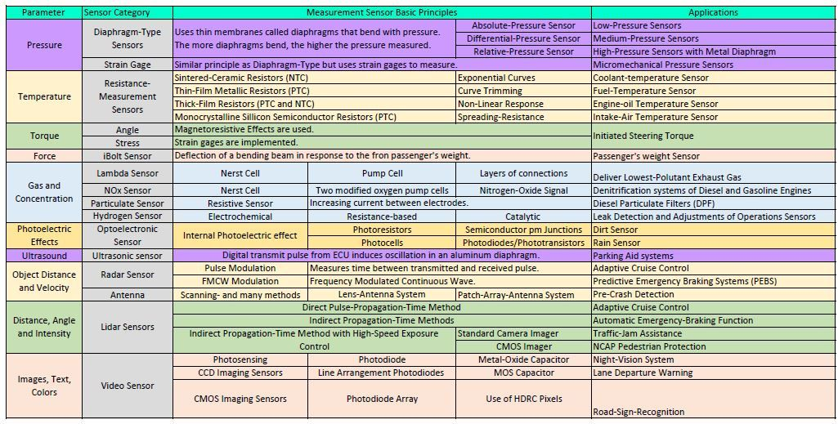

* 1. Sensors Available on Current Vehicles

END of Document